**ASSIGNMENT 2**

**BIT 302**

**Software Engineering**



**Project Proposal**

**Covid Testing Information System (CTIS)**

**Prepared by:**

Team Leader: Pande Putu Rama Pratama Putra (E1700877)

Member: I Nengah Wahyudi Setiawan (E1700868)

Contact Details:

[ramapratama657@gmail.com](mailto:ramapratama657@gmail.com)

nengahwahyudi90[@gmail.com](mailto:sidi.meisanjaya2013@gmail.com)

2021/2022

Contents

Introduction 3

Use Case Diagram 4

Architectural Design 6

Design Class Diagram 7

Entity Relationship Diagram (ERD) 8

Sitemap 9

Wireframe 10

Introduction

Coronavirus or SARS-CoV-2 is a virus that attacks the respiratory system. This disease due to viral infection is called COVID-19. This virus causes minor respiratory problems, lung infections, and death. This virus can attack the elderly, children, adults, babies, pregnant women, and nursing mothers. This virus spreads very quickly and has spread to almost all countries including Indonesia in just a few months.

During a pandemic, hundreds to millions of people tested positive for Covid. Medical staff and medical centers have difficulties with the number of patients who have to be controlled and registered as suspended, quarantine, and patients who have recovered.

Therefore, we created the CTIS (Covid Testing Information System) website to help medical centers control and record test results from Covid patients. Also, we plan to create this website to be able to help patients track their status history and get information about Covid. The duration of making this application is 3 months to complete this application and duration of making this assignment 2 is 1 month.

# Use Case Diagram

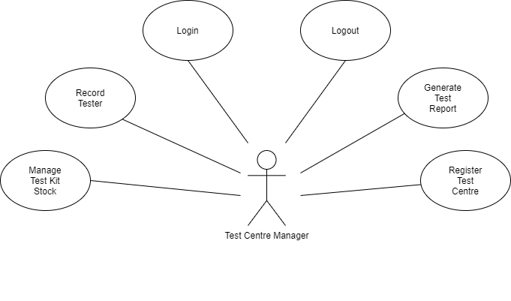

Use Case Diagram with Actor Test Centre Manager

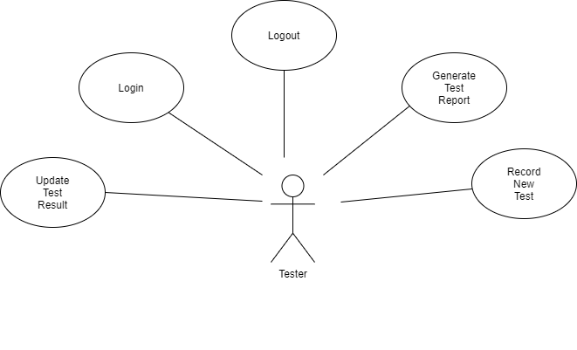

Use Case Diagram with Actor Tester

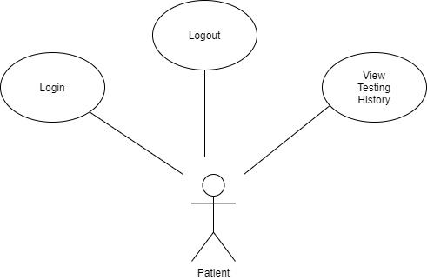

Use Case Diagram with Actor Patient

Architectural Design

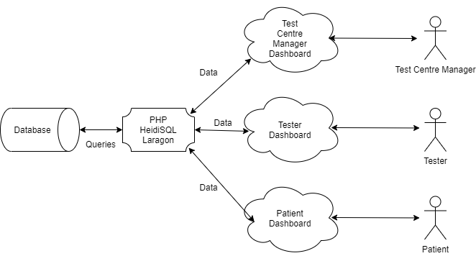

Design Class Diagram

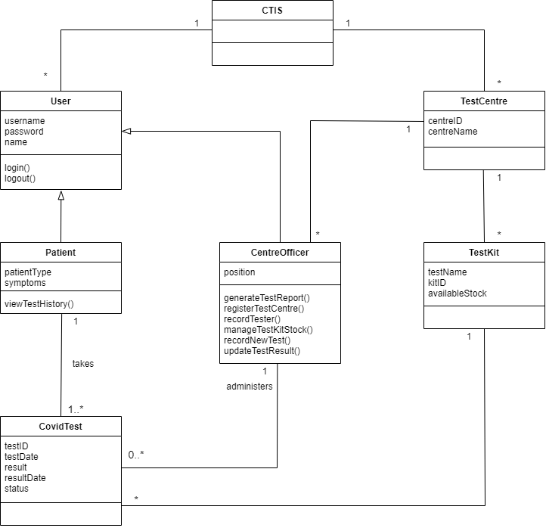

Entity Relationship Diagram (ERD)

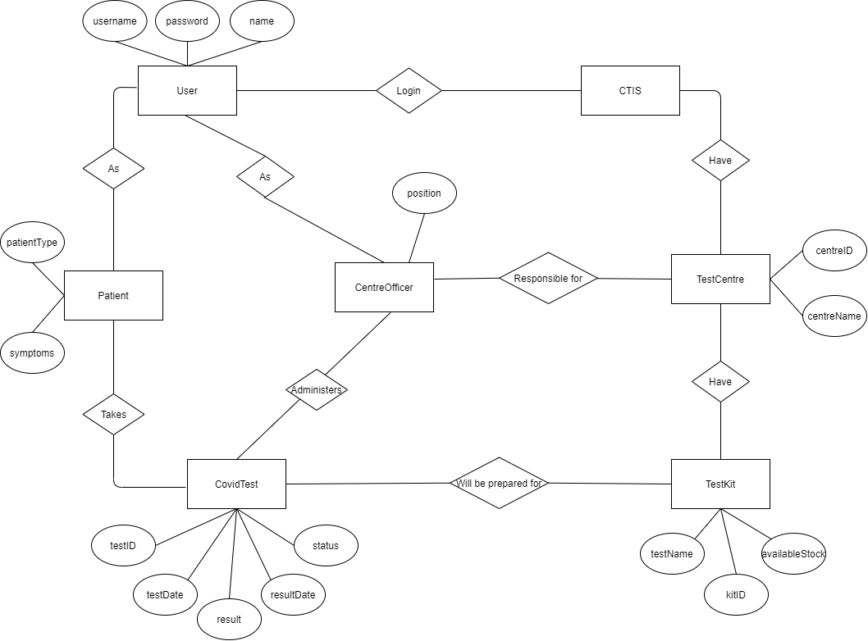

Sitemap

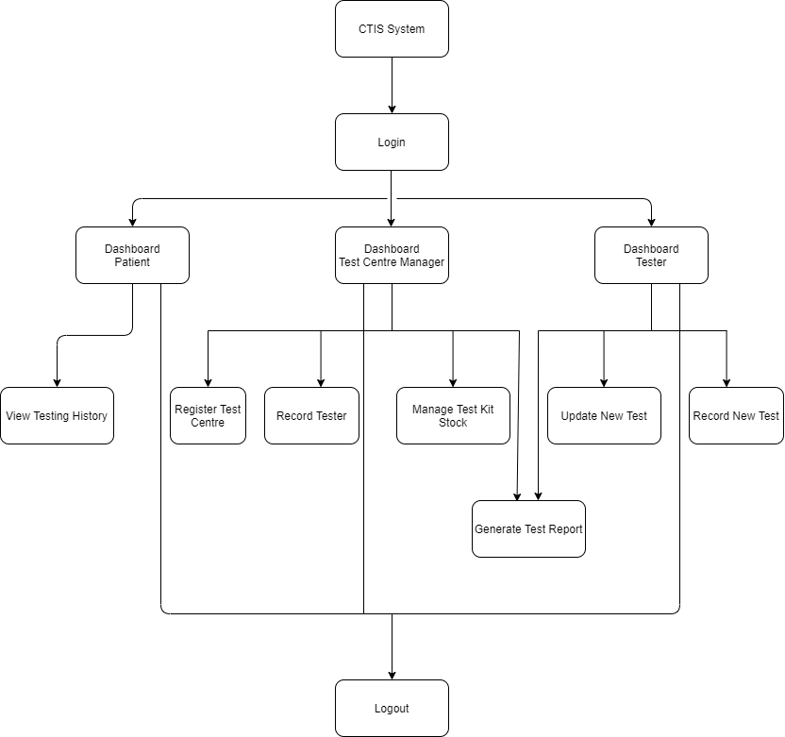

Wireframe

Login

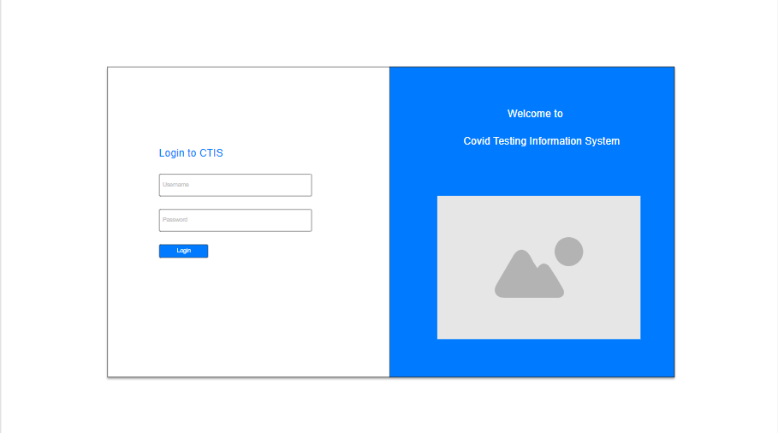

Test Centre Manager Dashboard

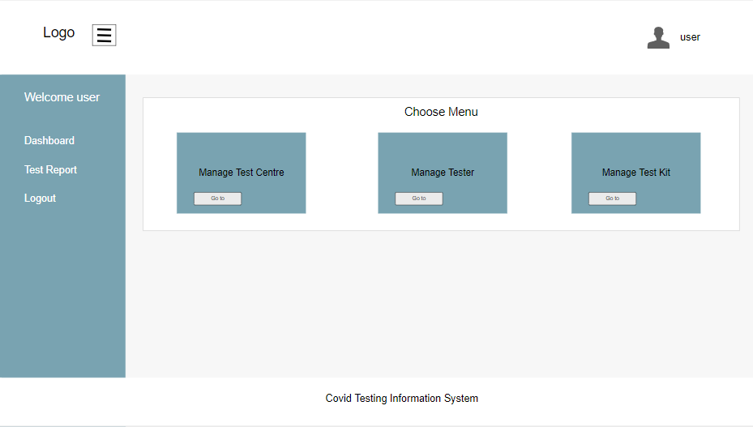

Manage Test Centre Page

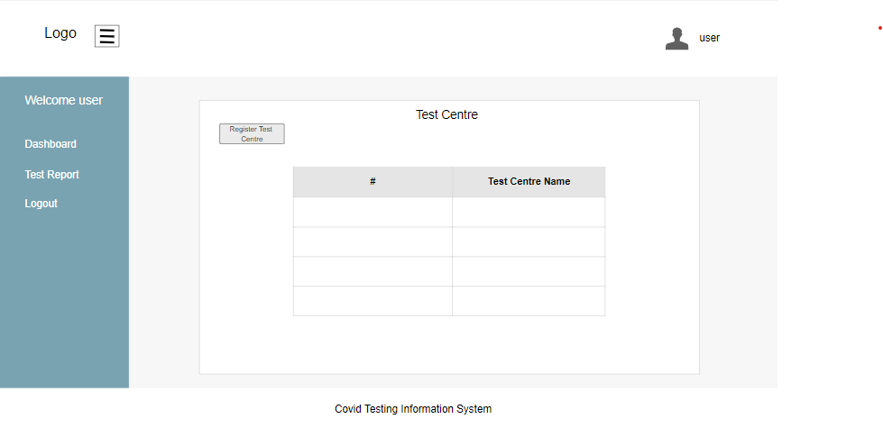

Register Test Centre Page

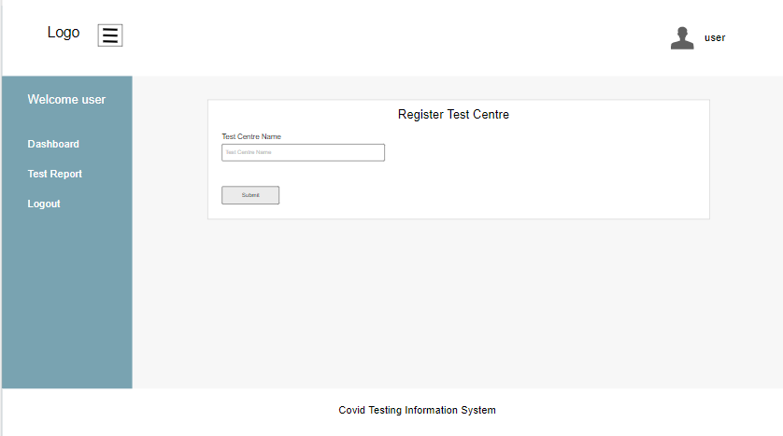

Manage Tester Page

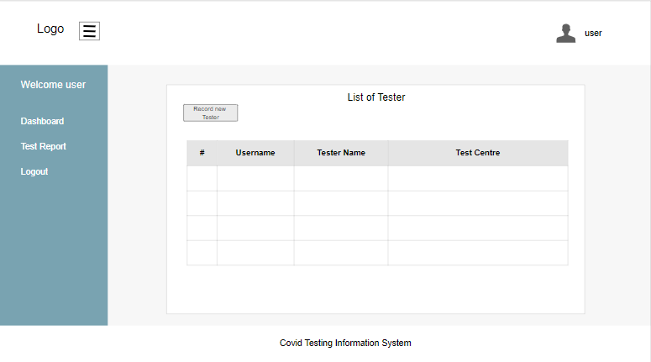

Record Tester Page

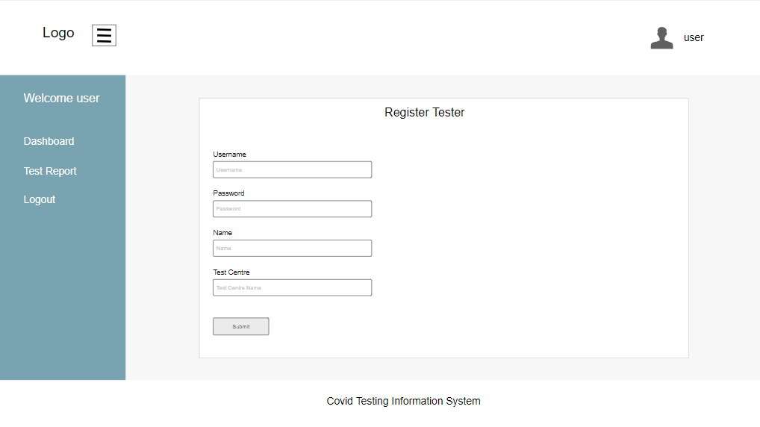

Manage Test Kit Stock

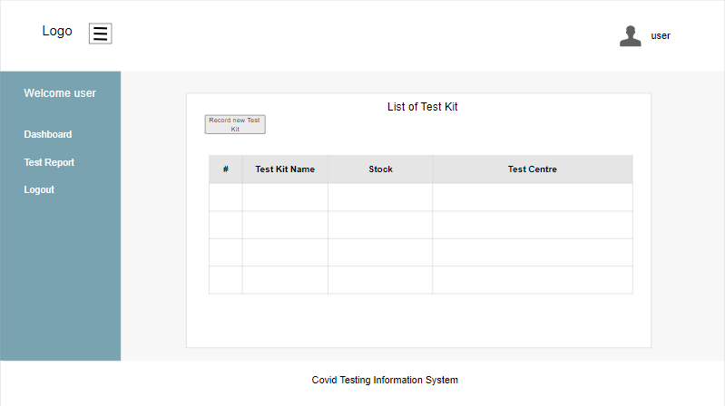

Record New Test Kit

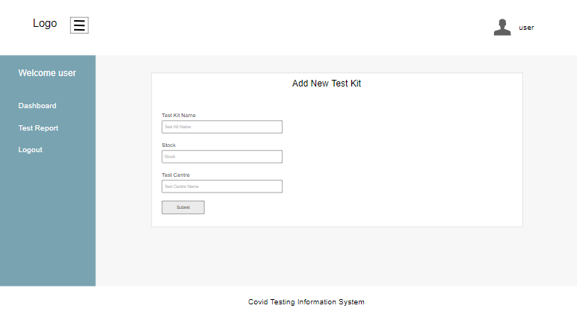

Generate Test Report

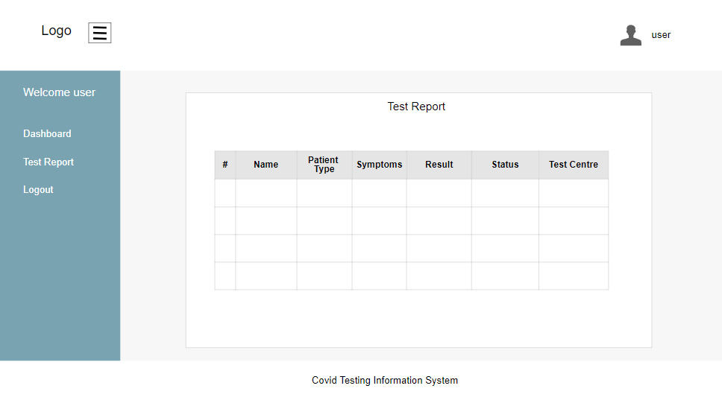

Tester Dashboard

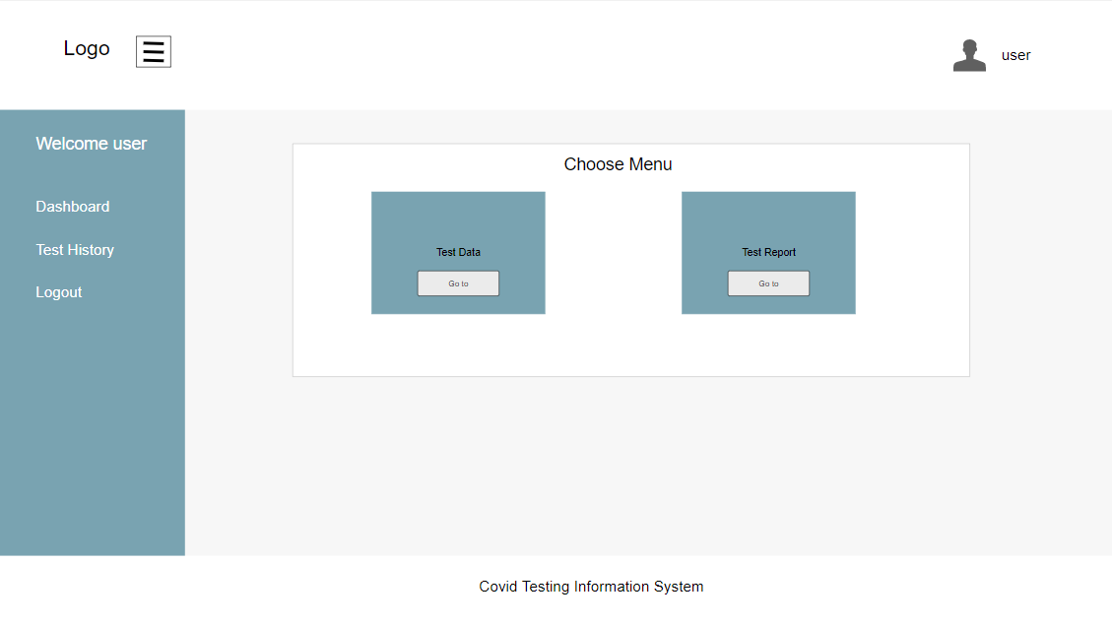

List Test Data Page

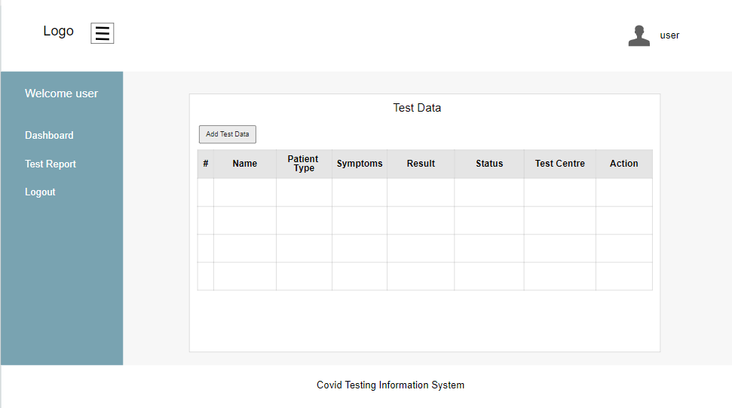

Record New Test Data

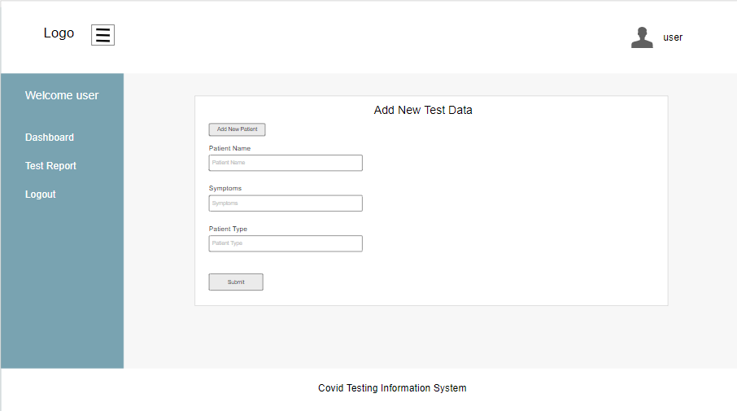

Record New Patient Data

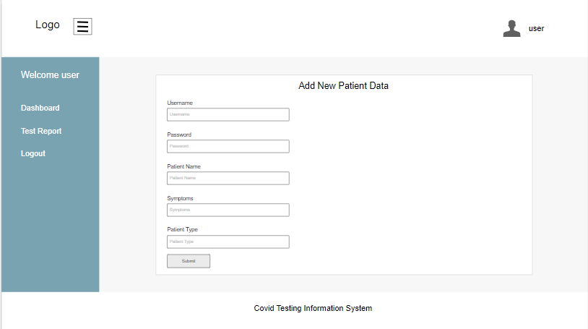

Update Test Result

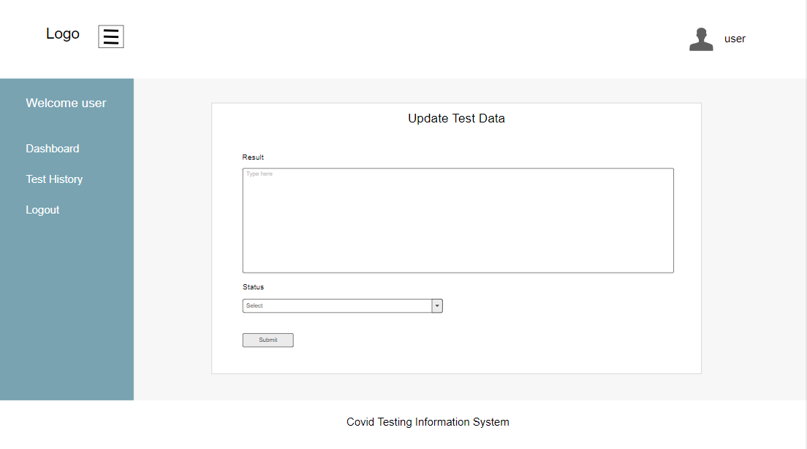

Patient Dashboard

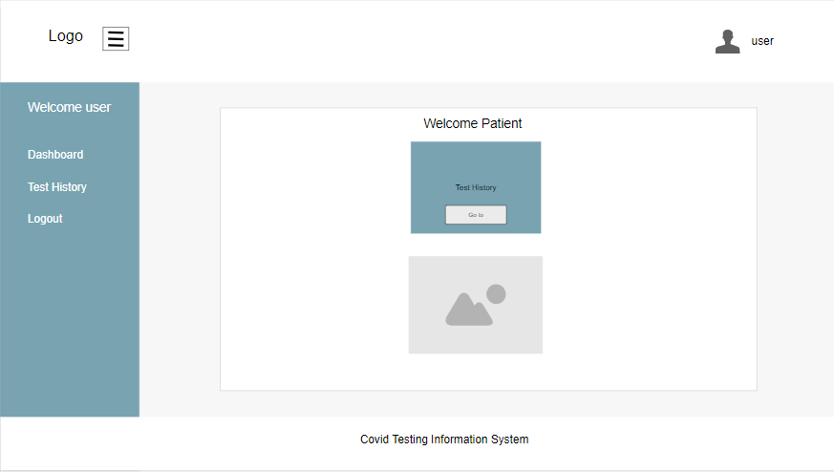

View Testing History Page

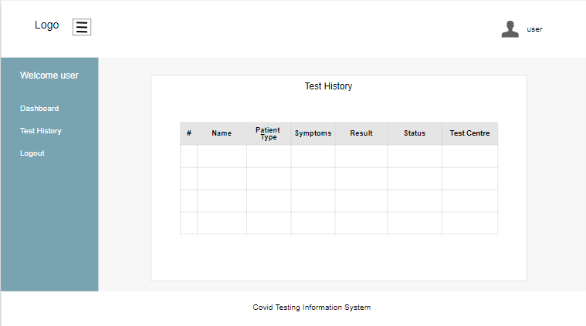

System Sequence Diagram + Contracts

1. Log In

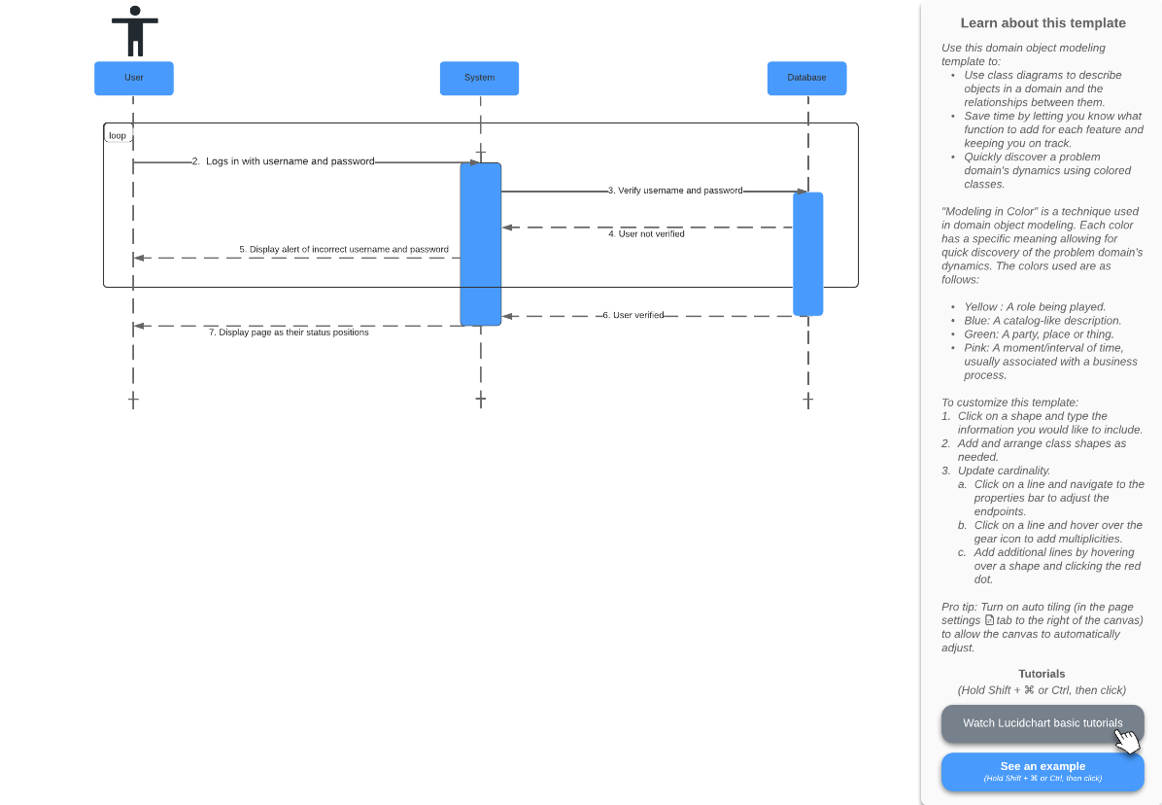

Prepared by: Pande Putu Rama Pratama Putra

|  |  |
| --- | --- |
| **Cross References** | **Login** |
| **Operation** | Login |
| **Responsible** | To display page as their status positions |
| **Pre-conditions** | * The username of user must be available * The password of user must be available |
| **Post-conditions** | * Username are matched according to names in database * Password are matched based on user’s password in database * Successfully displayed page as their status positions |

2. Register Test Centre

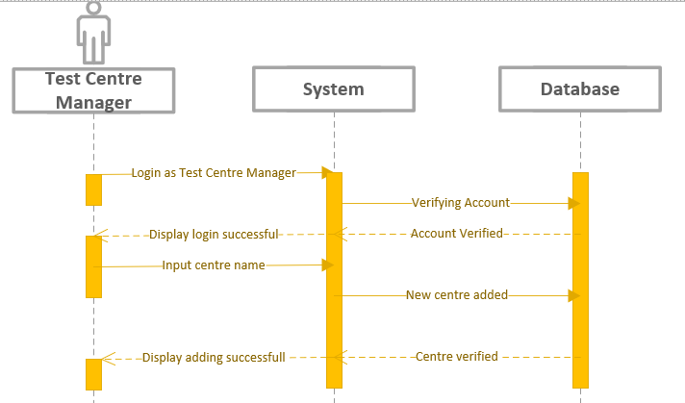

Prepared by: I Nengah Wahyudi Setiawan

|  |  |
| --- | --- |
| **Cross References** | **Register Test Centre** |
| **Operation** | Login |
| **Responsible** | To get access to page of test centre manager |
| **Pre-conditions** | * The username of user must be available * The password of user must be available |
| **Post-conditions** | * Username are matched according to names in database * Password are matched based on user’s password in database |

|  |  |
| --- | --- |
| **Cross References** | **Register Test Centre** |
| **Operation** | Input Centre Name |
| **Responsible** | To Register Test Centre |
| **Pre-conditions** | * Name of the Test Centre must be available |
| **Post-conditions** | * Test Centre’s name are successfully registered |

3. Record Tester

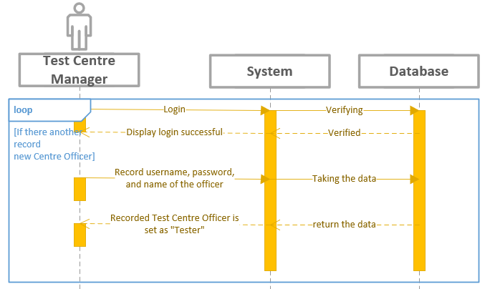

Prepared by: I Nengah Wahyudi Setiawan

|  |  |
| --- | --- |
| **Cross References** | **Record Tester** |
| **Operation** | Login |
| **Responsible** | To get access page of test centre manager |
| **Pre-conditions** | * The username of user must be available * The password of user must be available |
| **Post-conditions** | * Username are matched according to names in database * Password are matched based on user’s password in database |

|  |  |
| --- | --- |
| **Cross References** | **Record Tester** |
| **Operation** | Set and record the centre officer position as “Tester” |
| **Responsible** | To set the centre officer’s position to “Tester” |
| **Pre-conditions** | * The username of centre officer must be matched in database * The password of centre officer must be matched in database * The name of centre officer must be matched in database |
| **Post-conditions** | * Username are matched according to names in database * Password are matched based on user’s password in database * Name are matched based on user’s name in database * Positions status of the centre officer changed to “Tester” |

4. Manage Test Kit Stock

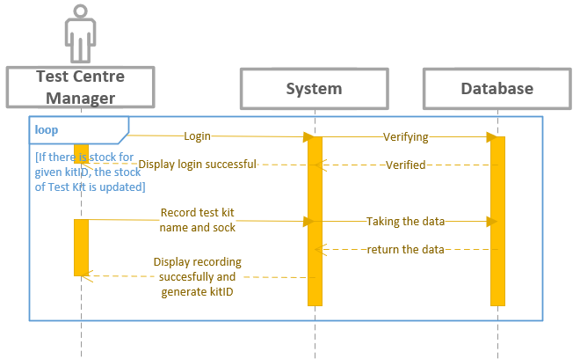

Prepared by: I Nengah Wahyudi Setiawan

|  |  |
| --- | --- |
| **Cross References** | **Manage Test Kit Stock** |
| **Operation** | Login |
| **Responsible** | To get access page of test centre manager |
| **Pre-conditions** | * The username of usermust be available * The password of user must be available |
| **Post-conditions** | * Username are matched according to names in database * Password are matched based on user’s password in database |

|  |  |
| --- | --- |
| **Cross References** | **Manage Test Kit Stock** |
| **Operation** | Record test kit |
| **Responsible** | To update test kit name and stock |
| **Pre-conditions** | * The name of test kit must available to record * The stock must know many available to record |
| **Post-conditions** | * Name of the test kit and stock are recorded and generate kitID |

5. Generate Test Report

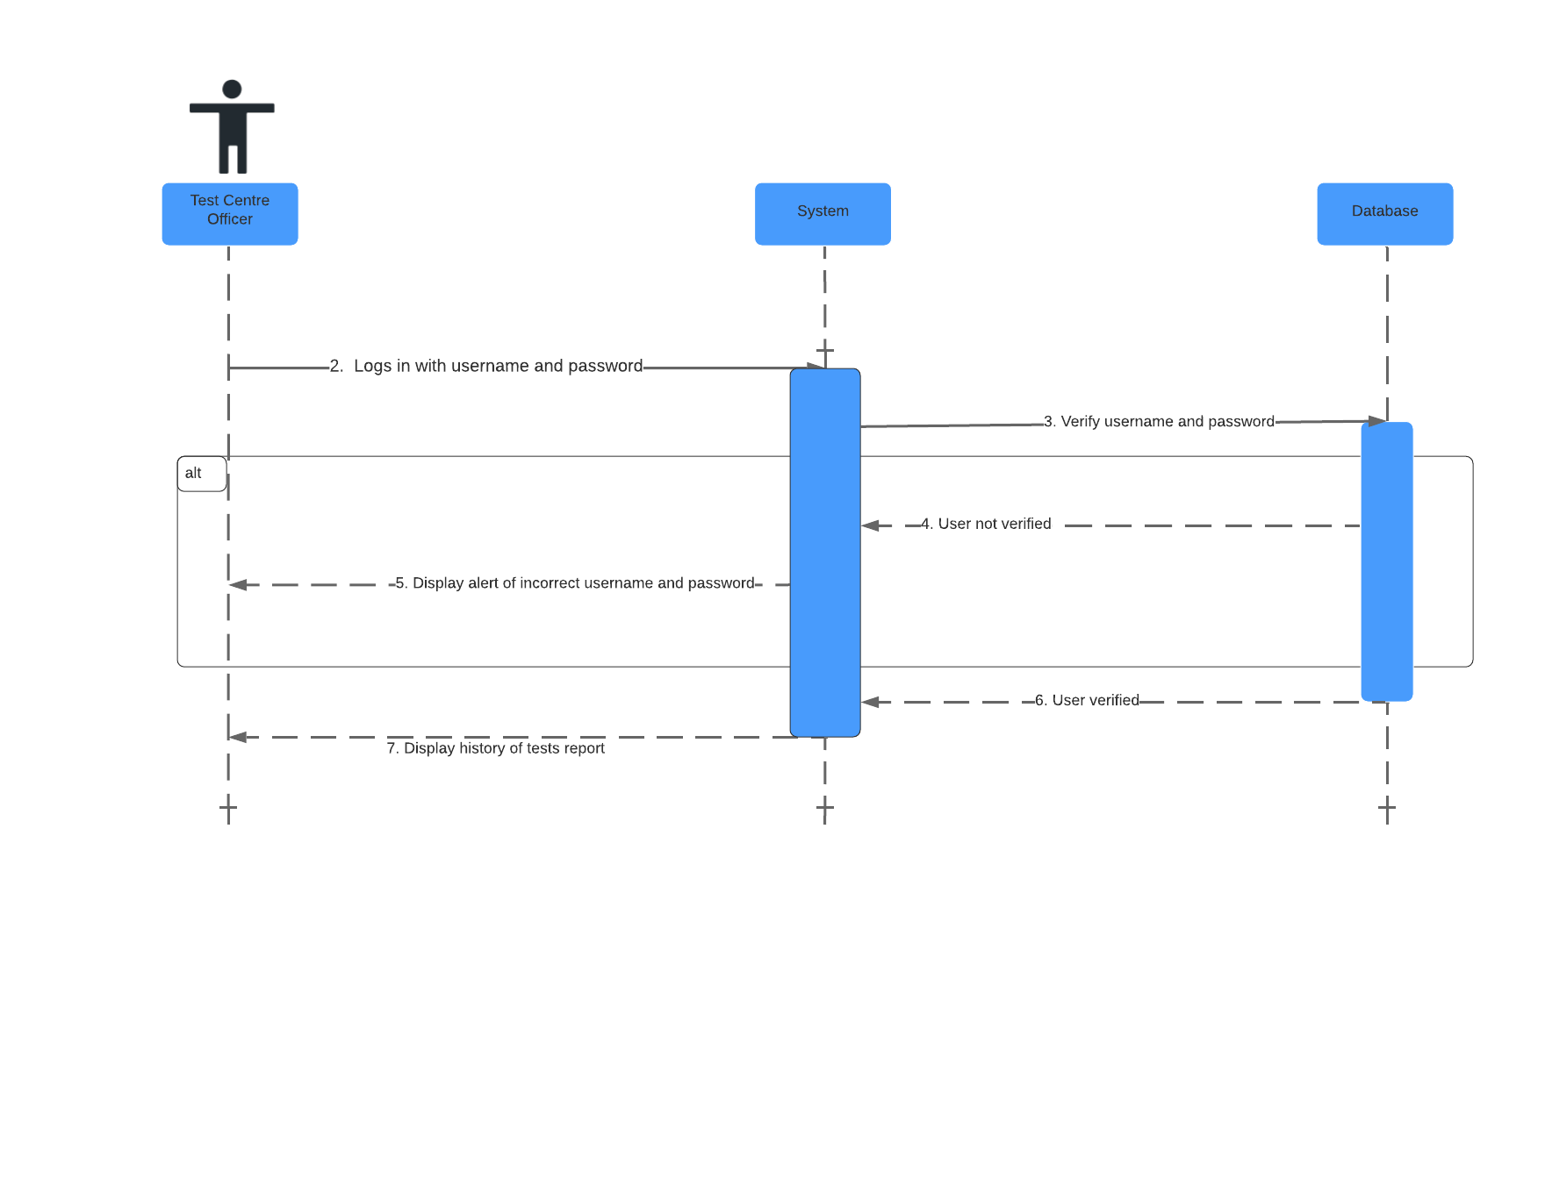

Prepared by: Pande Putu Rama Pratama Putra

|  |  |
| --- | --- |
| **Cross References** | **Generate Test Report** |
| **Operation** | Login username and password |
| **Responsible** | To get access page of test centre officer |
| **Pre-conditions** | * The username of user must be available * The password of user must be available |
| **Post-conditions** | * Username are matched according to names in database * Password are matched based on user’s password in database |

|  |  |
| --- | --- |
| **Cross References** | **Generate Test Report** |
| **Operation** | Display all history report |
| **Responsible** | To view all history of the report |
| **Pre-conditions** | * The report object must be available |
| **Post-conditions** | * All the report that administered is shown |

6. Record New Test

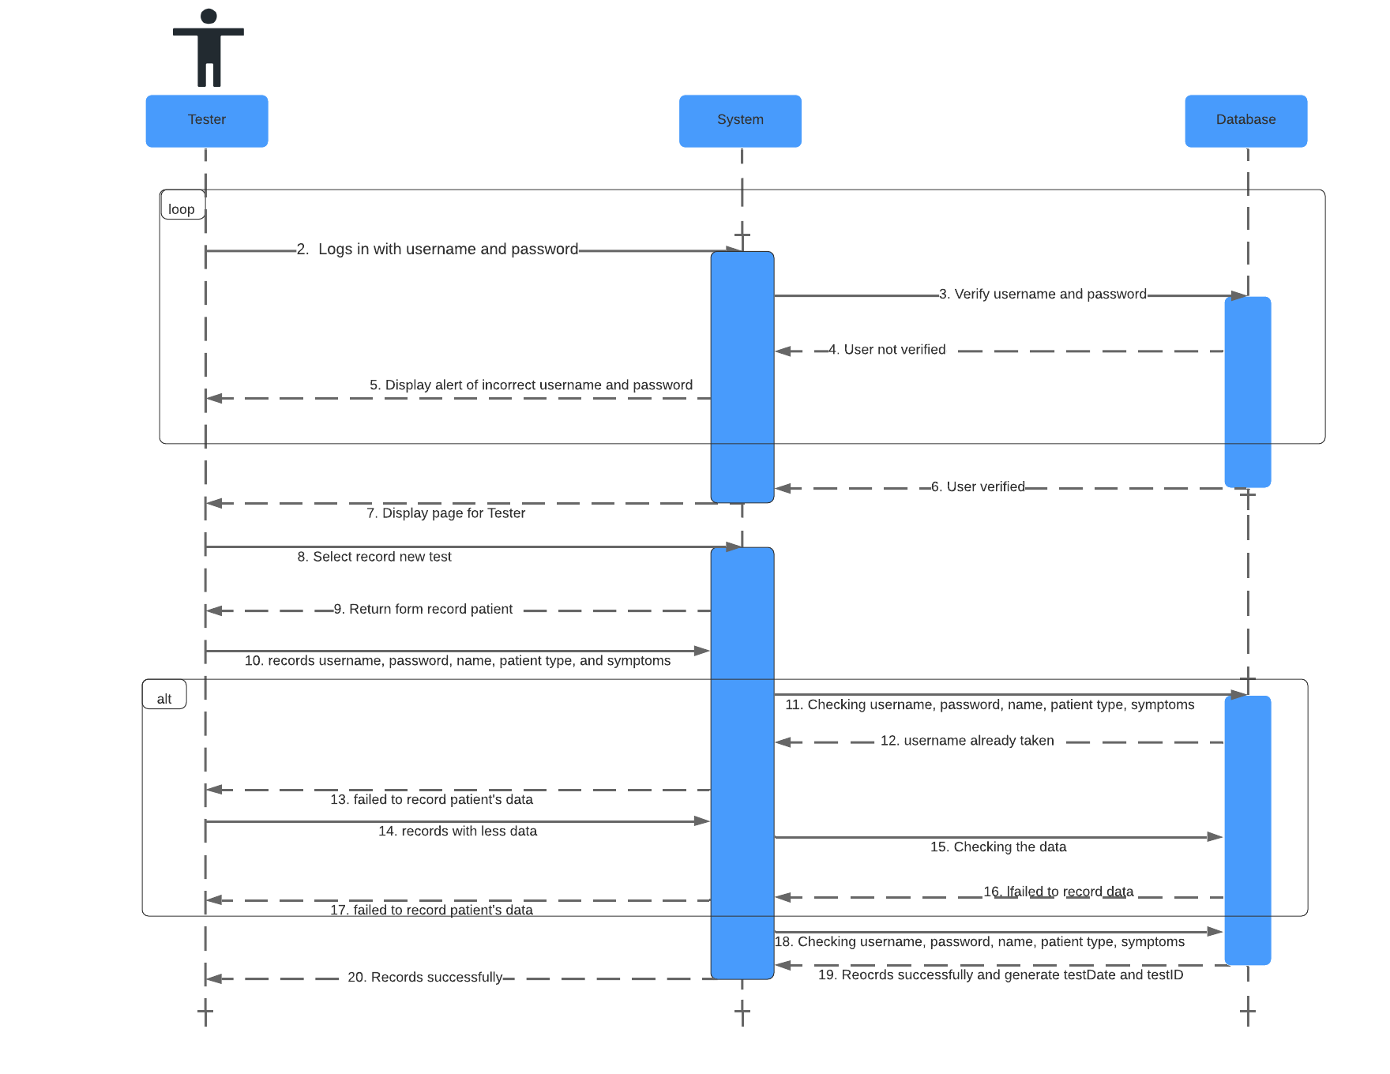

Prepared by: Pande Putu Rama Pratama Putra

|  |  |
| --- | --- |
| **Cross References** | **Record New Test** |
| **Operation** | Login username and password |
| **Responsible** | To get access page of tester |
| **Pre-conditions** | * The username of user must be available * The password of user must be available |
| **Post-conditions** | * Username are matched according to names in database * Password are matched based on user’s password in database |

|  |  |
| --- | --- |
| **Cross References** | **Record New Test** |
| **Operation** | Select record new test |
| **Responsible** | To get form of new test |
| **Pre-conditions** | * The form object must be available |
| **Post-conditions** | * Succesfully displayed form of new test |

|  |  |
| --- | --- |
| **Cross References** | **Record New Test** |
| **Operation** | Records username, password, name, patient type, and symptoms |
| **Responsible** | To record data of the patient |
| **Pre-conditions** | * The data object must be available |
| **Post-conditions** | * Succesfully record data of the patients * Successfully generate date of test and testID |

7. Update Test Result

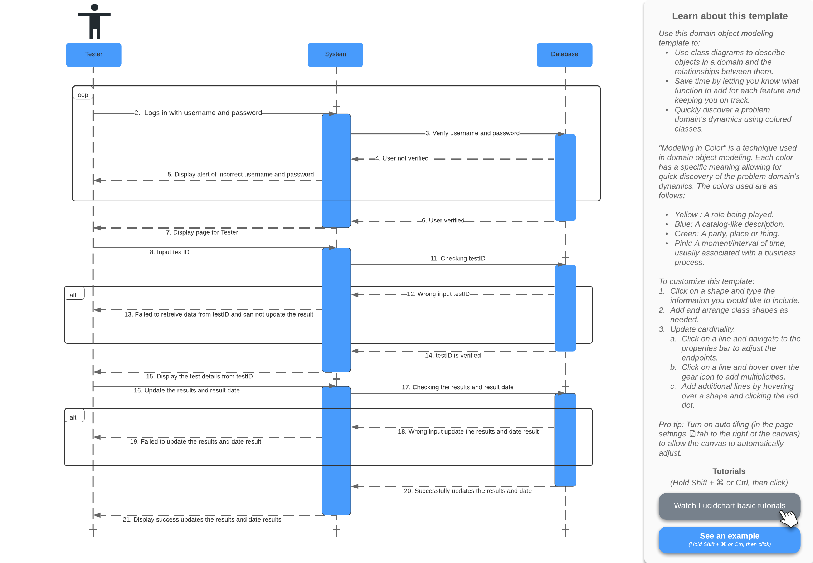

Prepared by: Pande Putu Rama Pratama Putra

|  |  |
| --- | --- |
| **Cross References** | **Update Test Results** |
| **Operation** | Login username and password |
| **Responsible** | To get access page of tester |
| **Pre-conditions** | * The username of user must be available * The password of user must be available |
| **Post-conditions** | * Username are matched according to names in database * Password are matched based on user’s password in database |

|  |  |
| --- | --- |
| **Cross References** | **Update Test Results** |
| **Operation** | Input testID |
| **Responsible** | To get data test from testID |
| **Pre-conditions** | * The testID object must be available |
| **Post-conditions** | * Successfully display test details from testID |

|  |  |
| --- | --- |
| **Cross References** | **Update Test Results** |
| **Operation** | Input date of test and result test |
| **Responsible** | To update the result of the test |
| **Pre-conditions** | * The date of test and result object must be available |
| **Post-conditions** | * Successfully update date of test and result test |

8. View Testing History

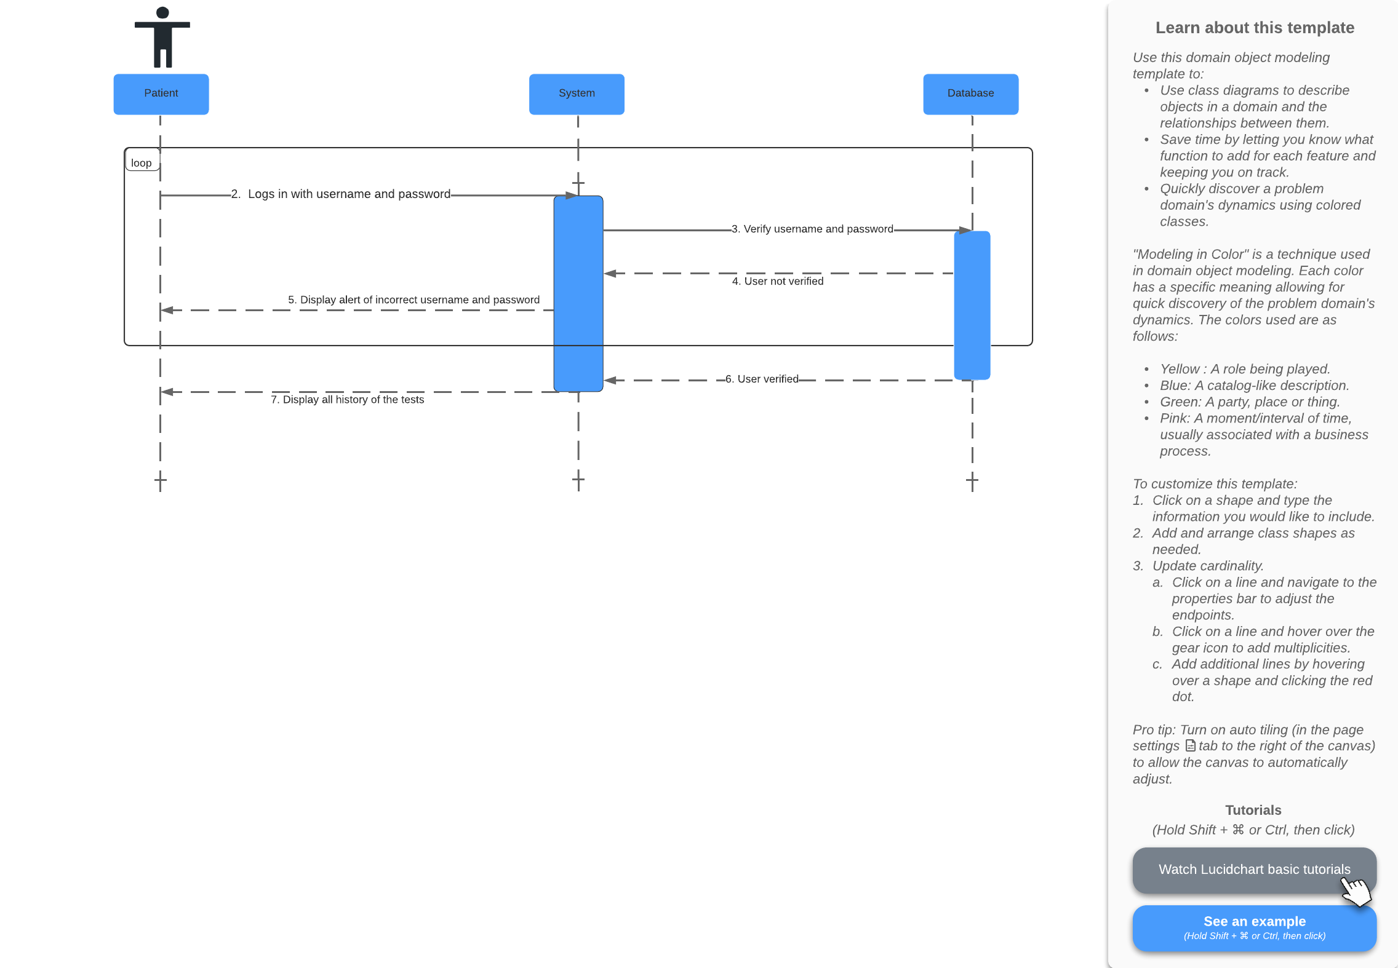

Prepared by: Pande Putu Rama Pratama Putra

|  |  |
| --- | --- |
| **Cross References** | **View Testing History** |
| **Operation** | Login username and password |
| **Responsible** | To display all history of the tests |
| **Pre-conditions** | * The username of user must be available * The password of user must be available |
| **Post-conditions** | * Username are matched according to names in database * Password are matched based on user’s password in database * Successfully displayed all history of the tests |

9. Log Out

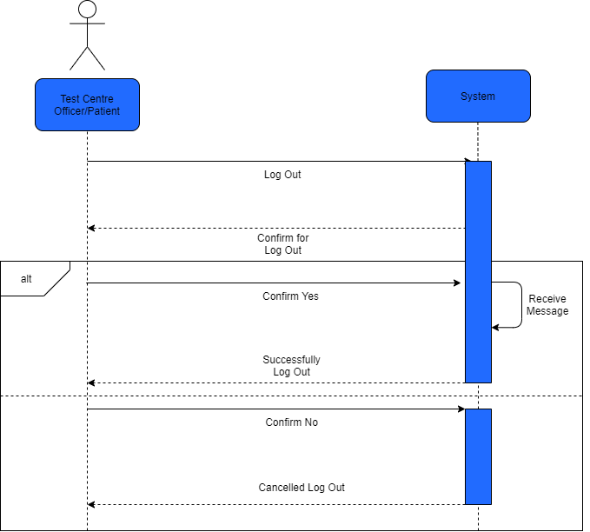

Prepared by: Pande Putu Rama Pratama Putra

|  |  |
| --- | --- |
| **Cross References** | **Logout** |
| **Operation** | Log Out User |
| **Responsible** | To log out user profile test centre officer / patient from system |
| **Pre-conditions** | * The user confirm yes to log out from system |
| **Post-conditions** | * The user successfully log out |

|  |  |
| --- | --- |
| **Cross References** | **Logout** |
| **Operation** | Cancel Log Out User |
| **Responsible** | To cancel log out user profile test centre officer / patient from system |
| **Pre-conditions** | * The user confirm no to log out from system |
| **Post-conditions** | * The user cancelled log out |

Database Design

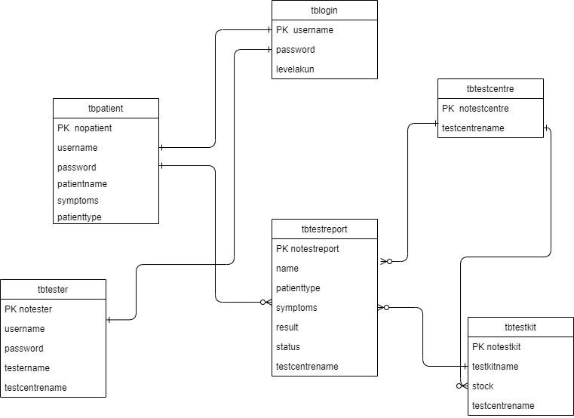

Iteration 1

Use Case

|  |  |  |
| --- | --- | --- |
| Use Case | Developed By | Testing |
| Login | Rama | Iteration 1 |
| Log Out | Rama | Iteration 1 |
| Generate Test Report (Test Centre Officer) | Rama | Iteration 1 |
| Register Test Centre (Test Centre Manager) | Wahyudi | Iteration 1 |
| Record Tester (Test Centre Manager) | Wahyudi | Iteration 1 |
| Manage Test Kit Stock (Test Centre Manager) | Wahyudi | Iteration 1 |
| Record New Test (Tester) | Rama | Iteration 1 |
| Update Test Result (Tester) | Rama | Iteration 1 |
| View Testing History (Patient) | Rama | Iteration 1 |

Test Objectives

The objective of testing this system is to find bug and error in the application. With testing, it will build application that be very robust and can run smoothly. Altough, we still build-and-testing for make user that can use the application easily and user-friendly. Beside for finding bug and error, the objective of testing is, we can analyze the system and we can put more features for this application.

Our first objective on CTIS system is to make sure the user can login successfully and encrypted with encryption provided by the framework that we use to work. After that, we test the application(the pages) to ensure that working properly. Beside the pages, we also test all the links, button, etc are work properly and directing to the right pages. We test the system according to the role:

* As Test Centre Manager and Tester, user should be able to do basic Create, Read, Update, Delete (CRUD) operation in the system on certain object, like test centre, test kit, test report, etc.
* As Patient, user should be able to view data only to his role and application, like test history.

Test Plan

For the information system, we will be testing Login system, so that Test Centre Manager, Tester, and Patient will directed to their own dashboard page. Beside that, we also testing functions that will be performed by Test Centre Manager, Tester, and Patient. We want to make sure that system boundaries are working properly, like Patient can only view the data and can not edit or delete data.

Unit Testing

1. Login

This is login function that user can log in as their positions. And it will direct to their own dashboard page

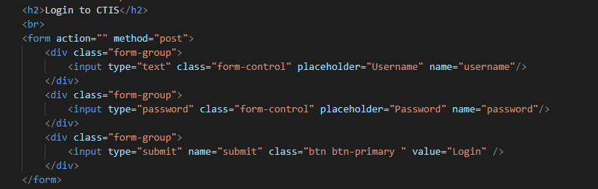

This function is use to validate input from user when log in. If the username and password are not registered or wrong input, it will display message error.

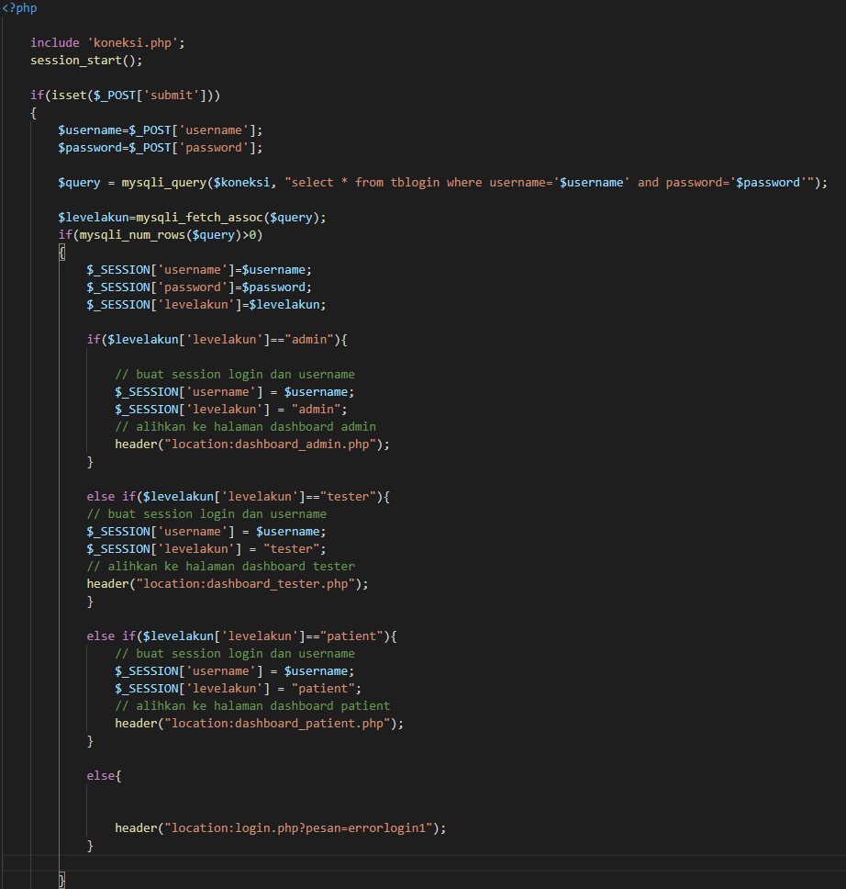

This function is use to connect to database localhost

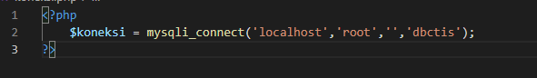

This is Log in Page

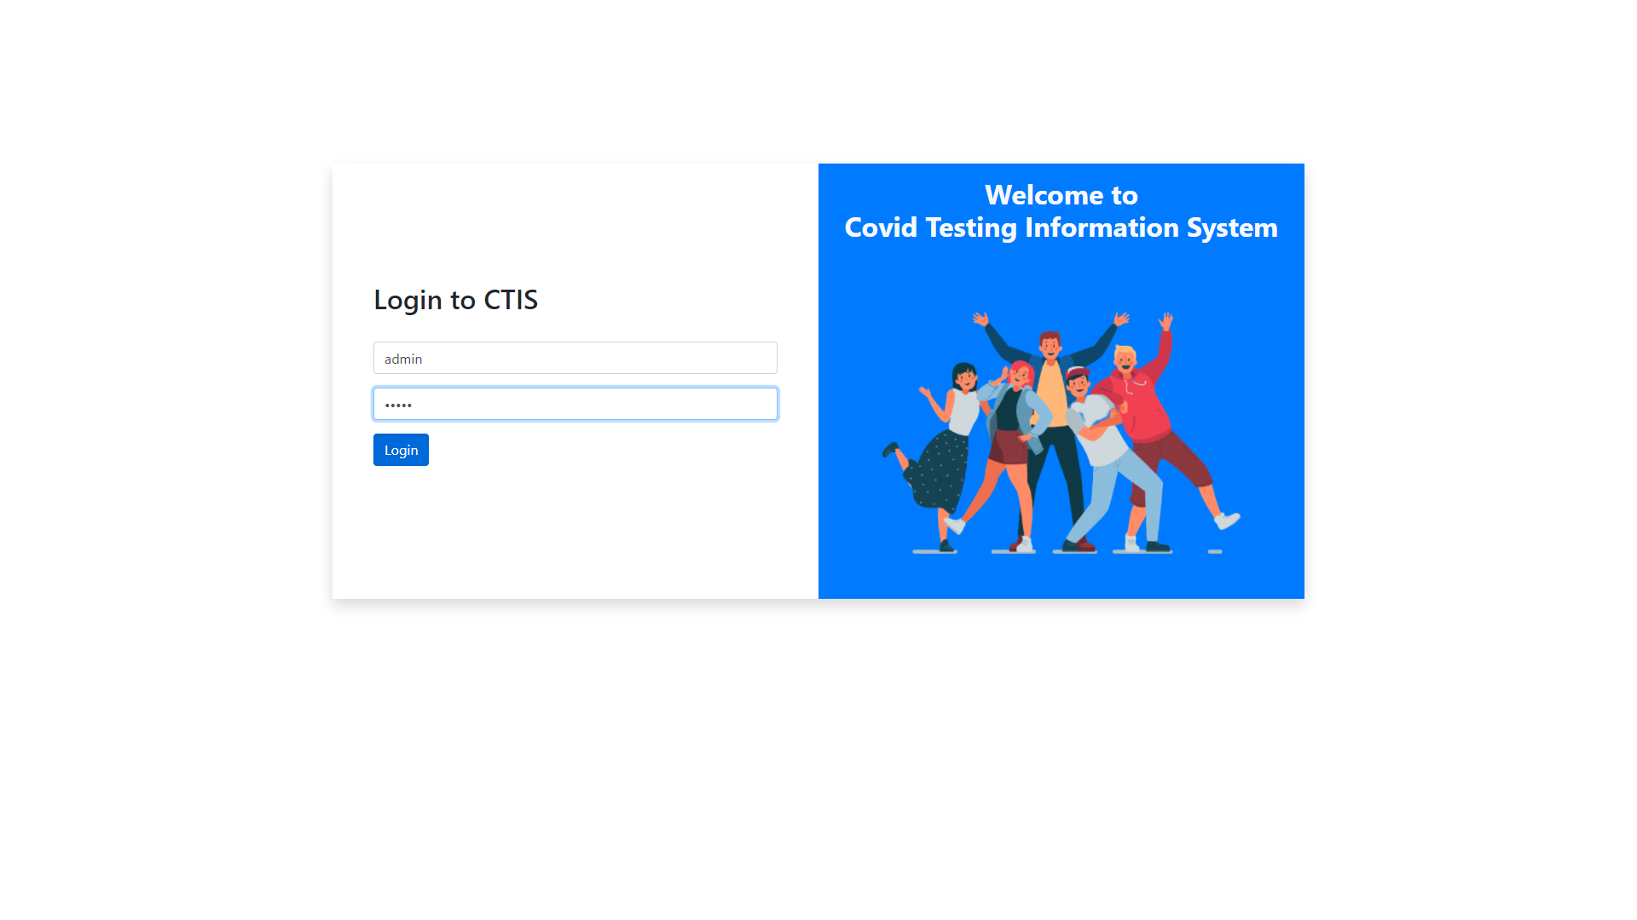

This is Test Centre Manager’s Dashboard

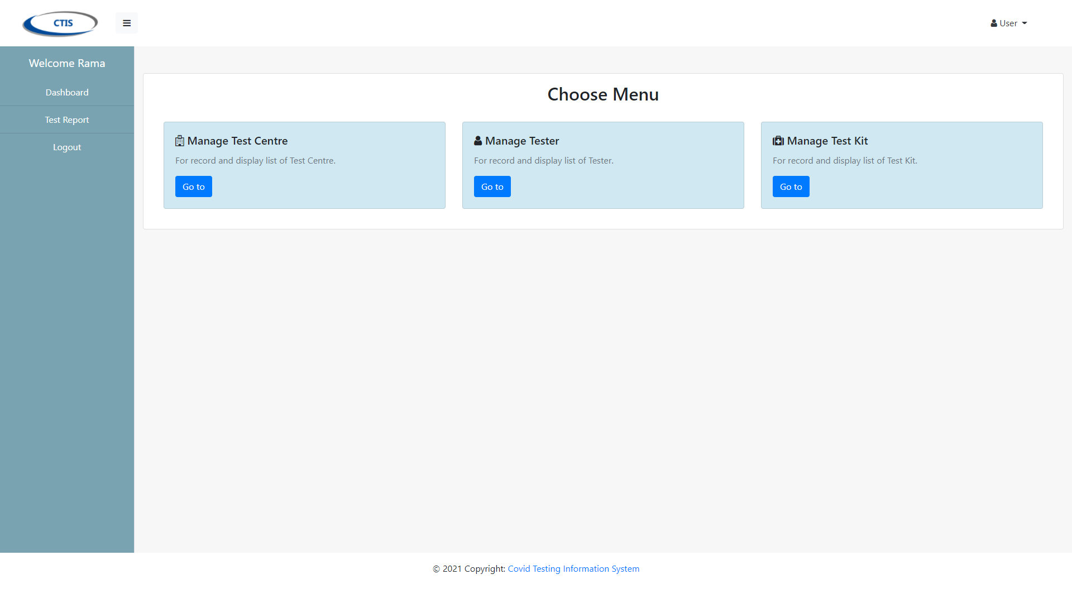

This is Tester’s Dashboard

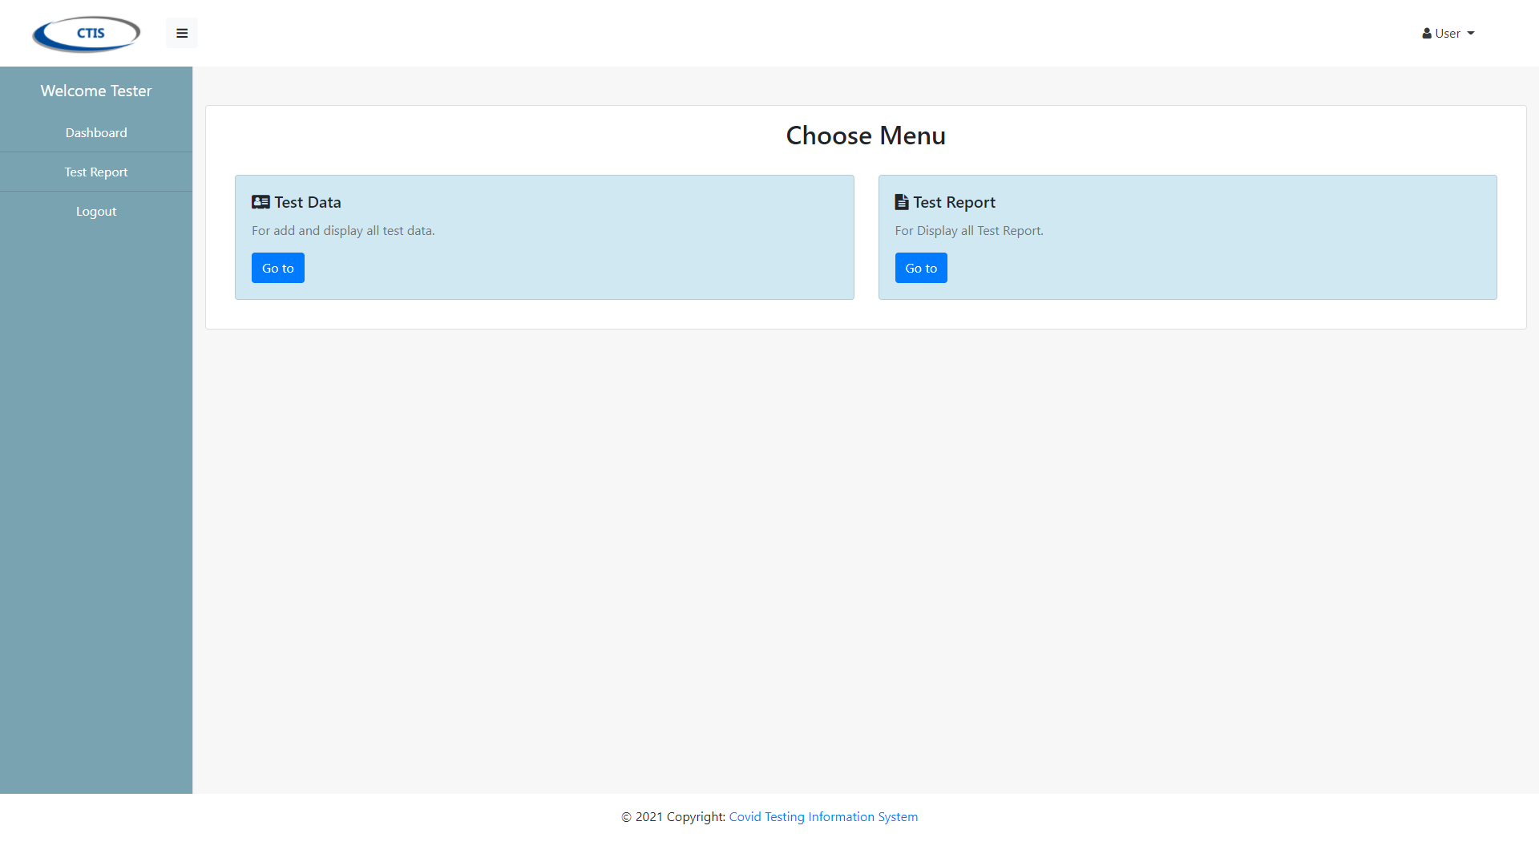

This is Patient’s Dashboard

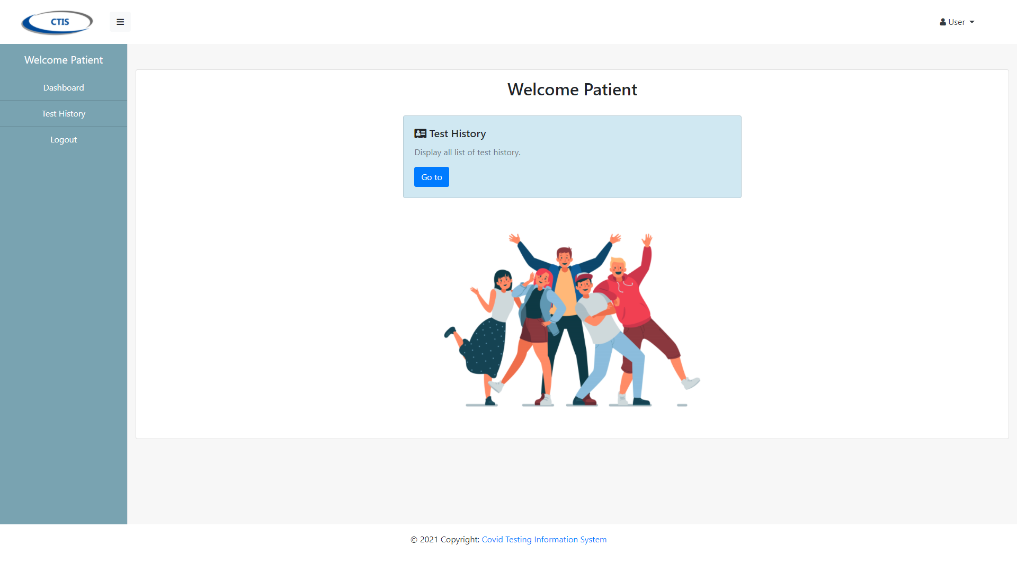

2. Manage Test Centre

This function is to display list all the data of test centre that has been registered

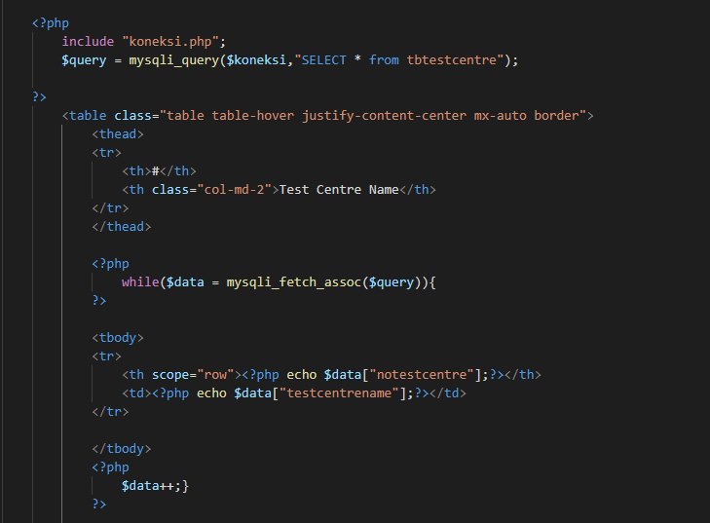

This page is display all the test centre that has been registered

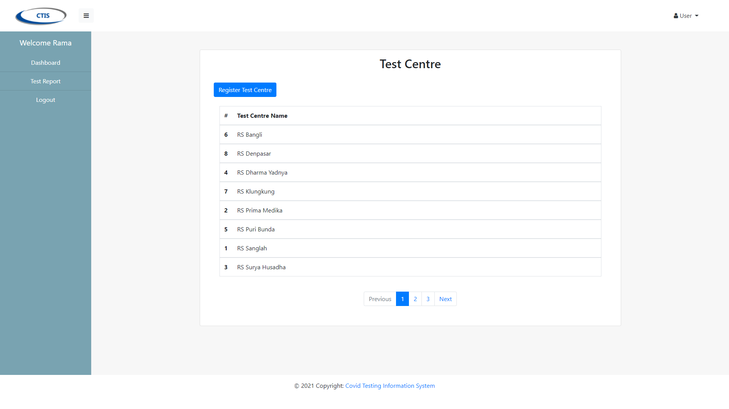

This function is to registered the test centre from test centre manager

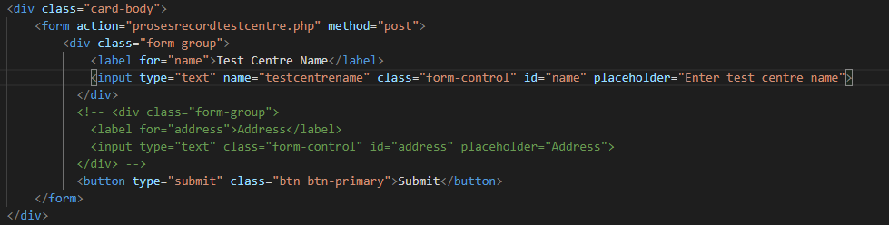

This page is display form registration of test centre

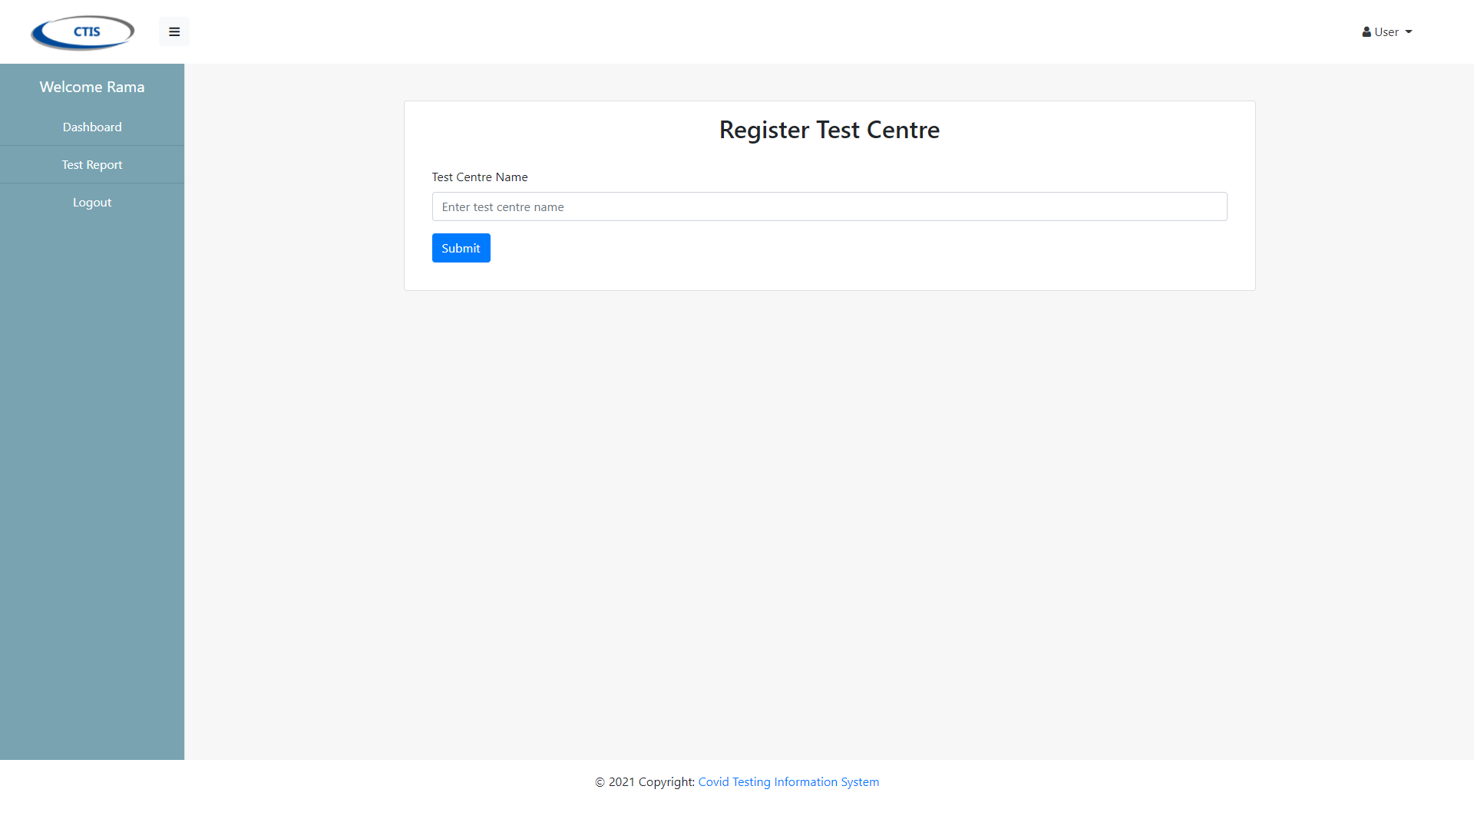

This function is to proceess record the test centre

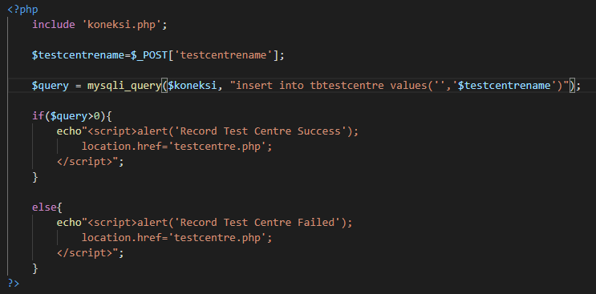

3. Record Tester

This function is use to display all list of tester that has been recorded

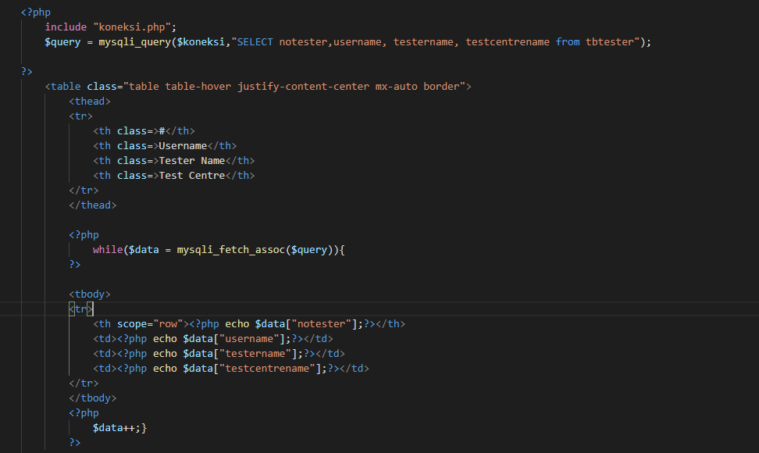

This page is display all the tester that has been recorded

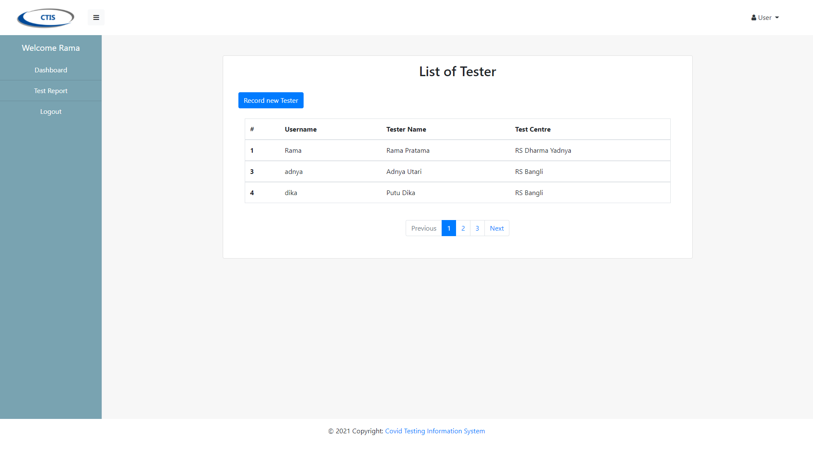

This function is use to record the new tester from test centre officer

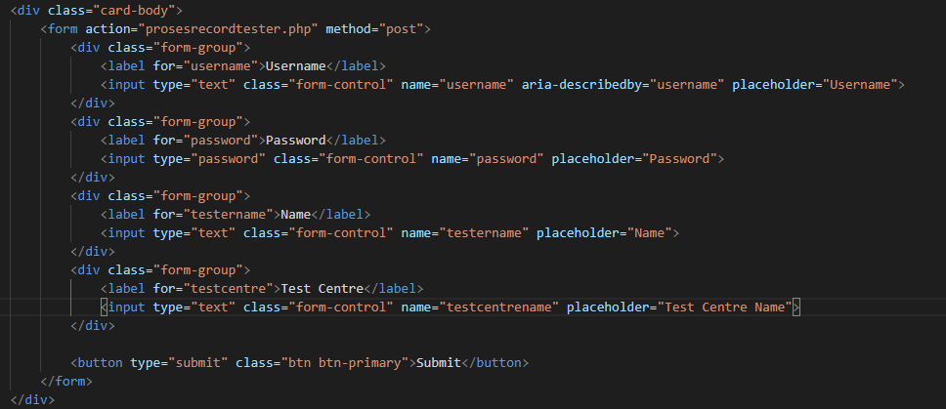

This page is display form record for tester

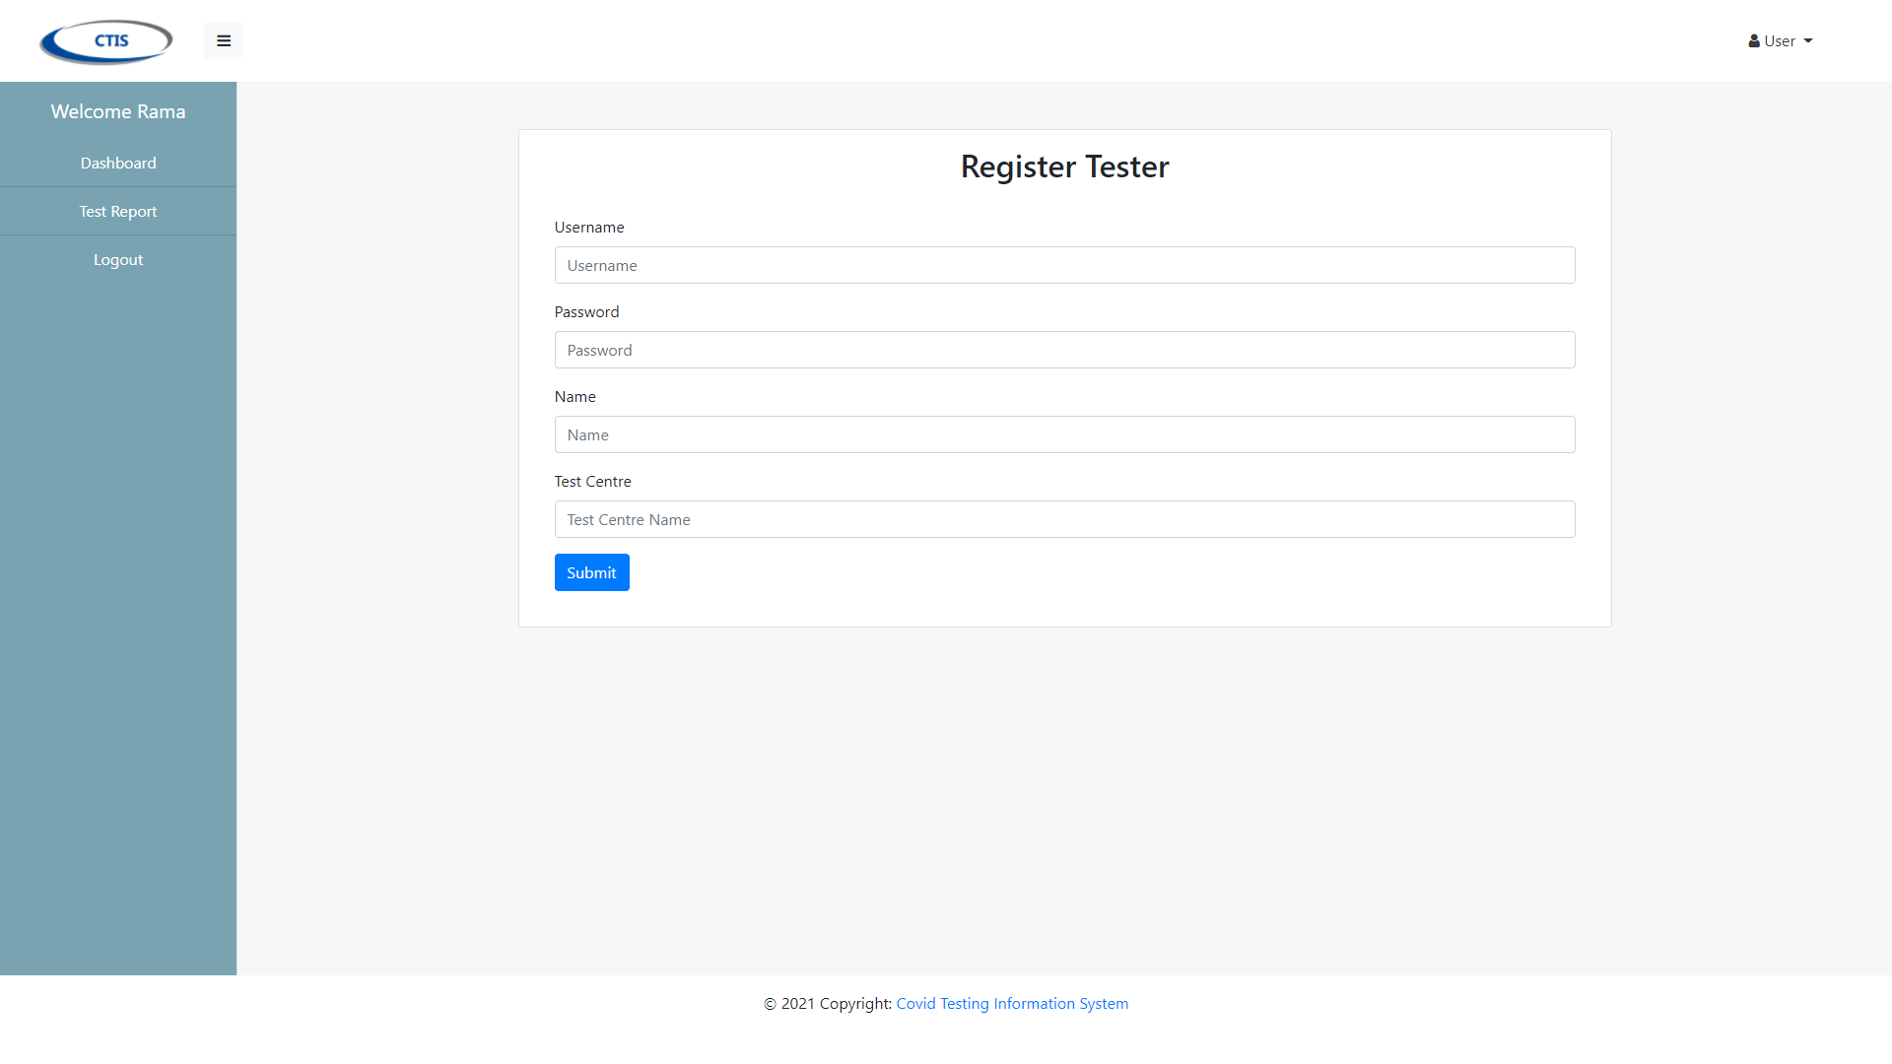

This function is use to proceess the record of new tester

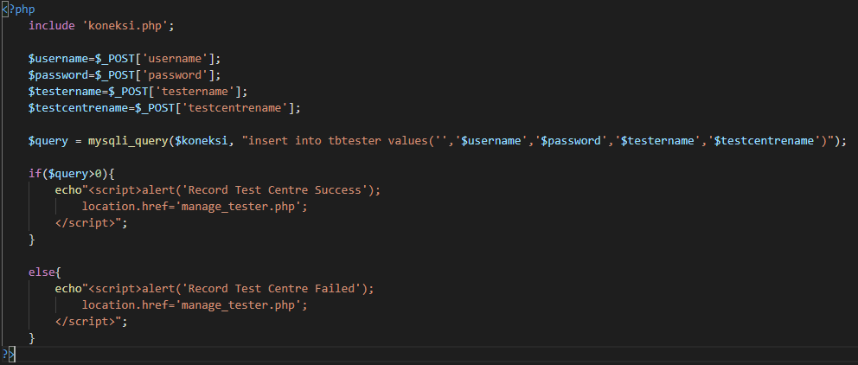

4. Manage Test Kit Stock

This function is use to display all the test kit stock that has been registered or updated

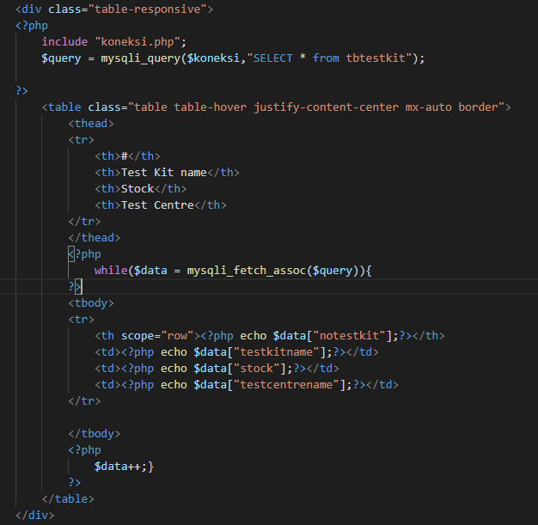

This page is display all the test kit that has been registered

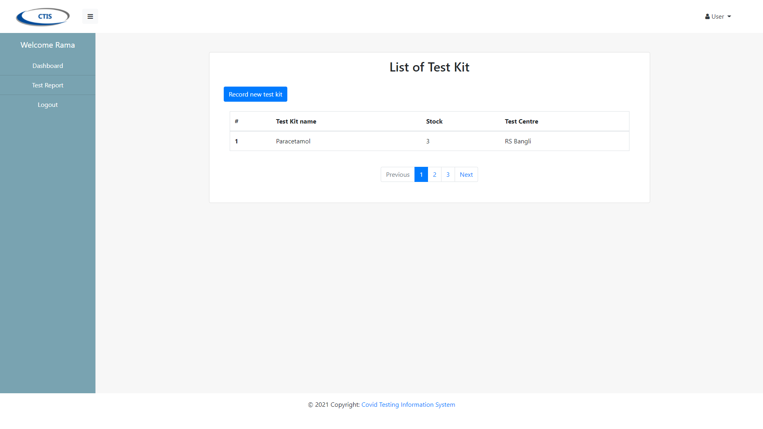

This function is use to register or update the test kit stock

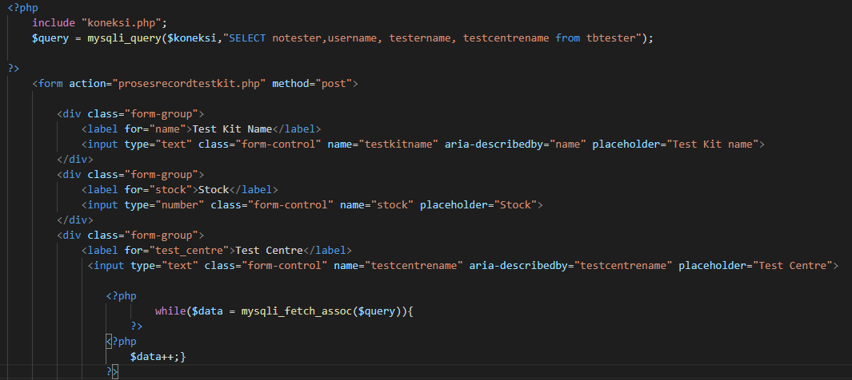

This page is display form of register test kit

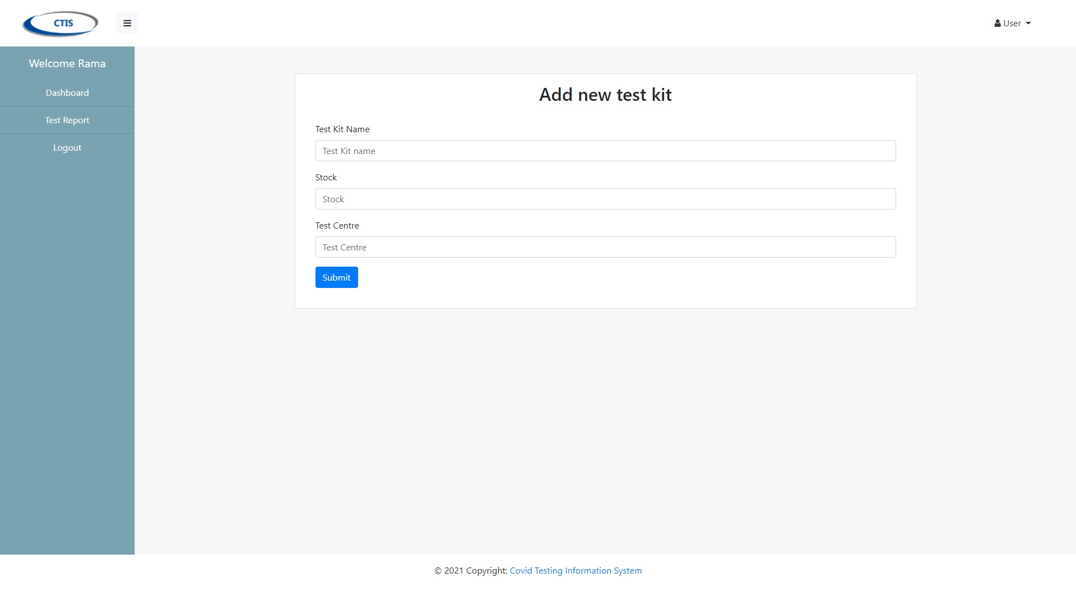

This function is use to proceess register the test kit

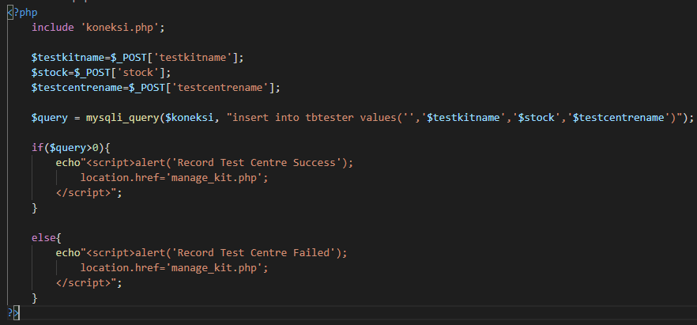

5. Generate Test Report

This function is display all the test that has been registered

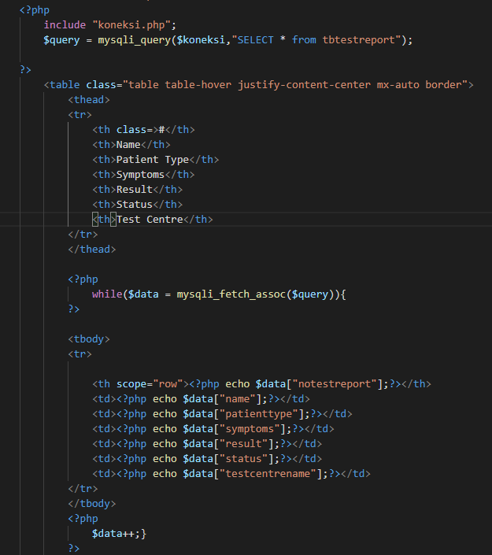

This page is display list all the test report that has been registered

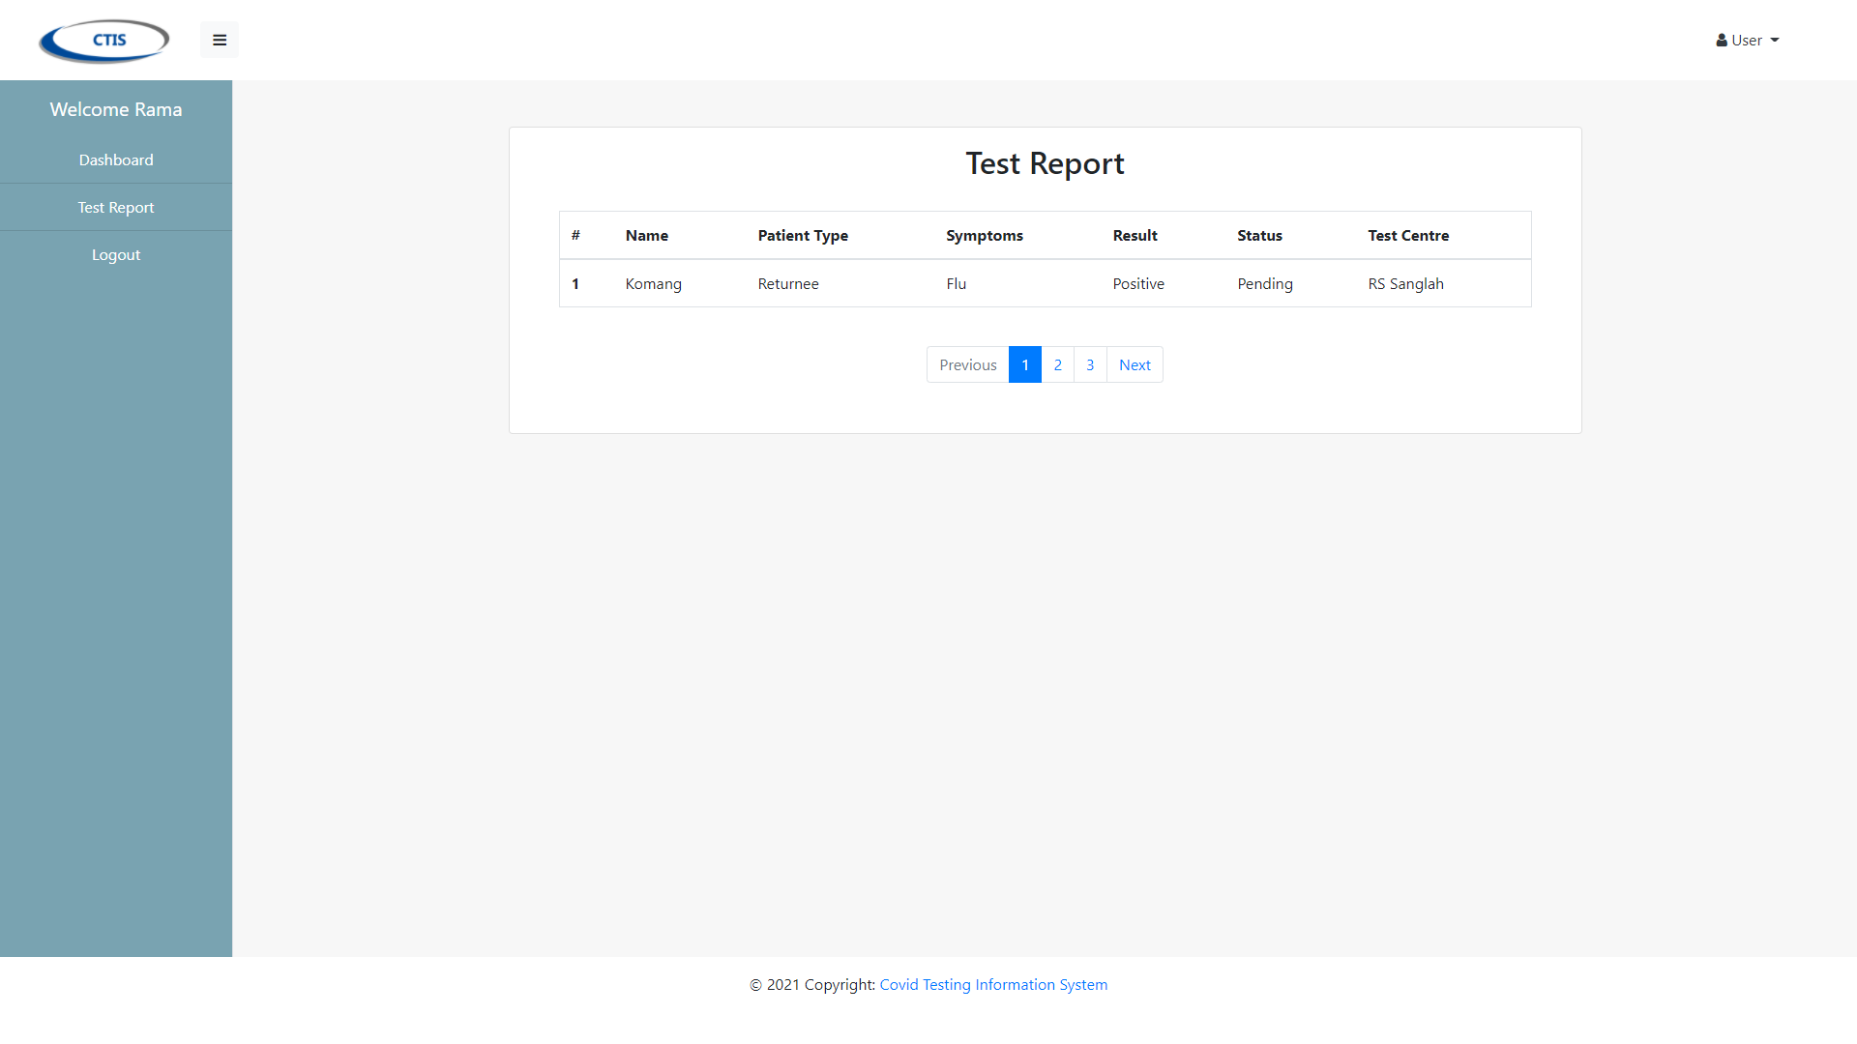

6. Logout

This function is use when user want to logut from application

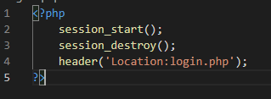

This is page from Test Centre Manager that user want to logout

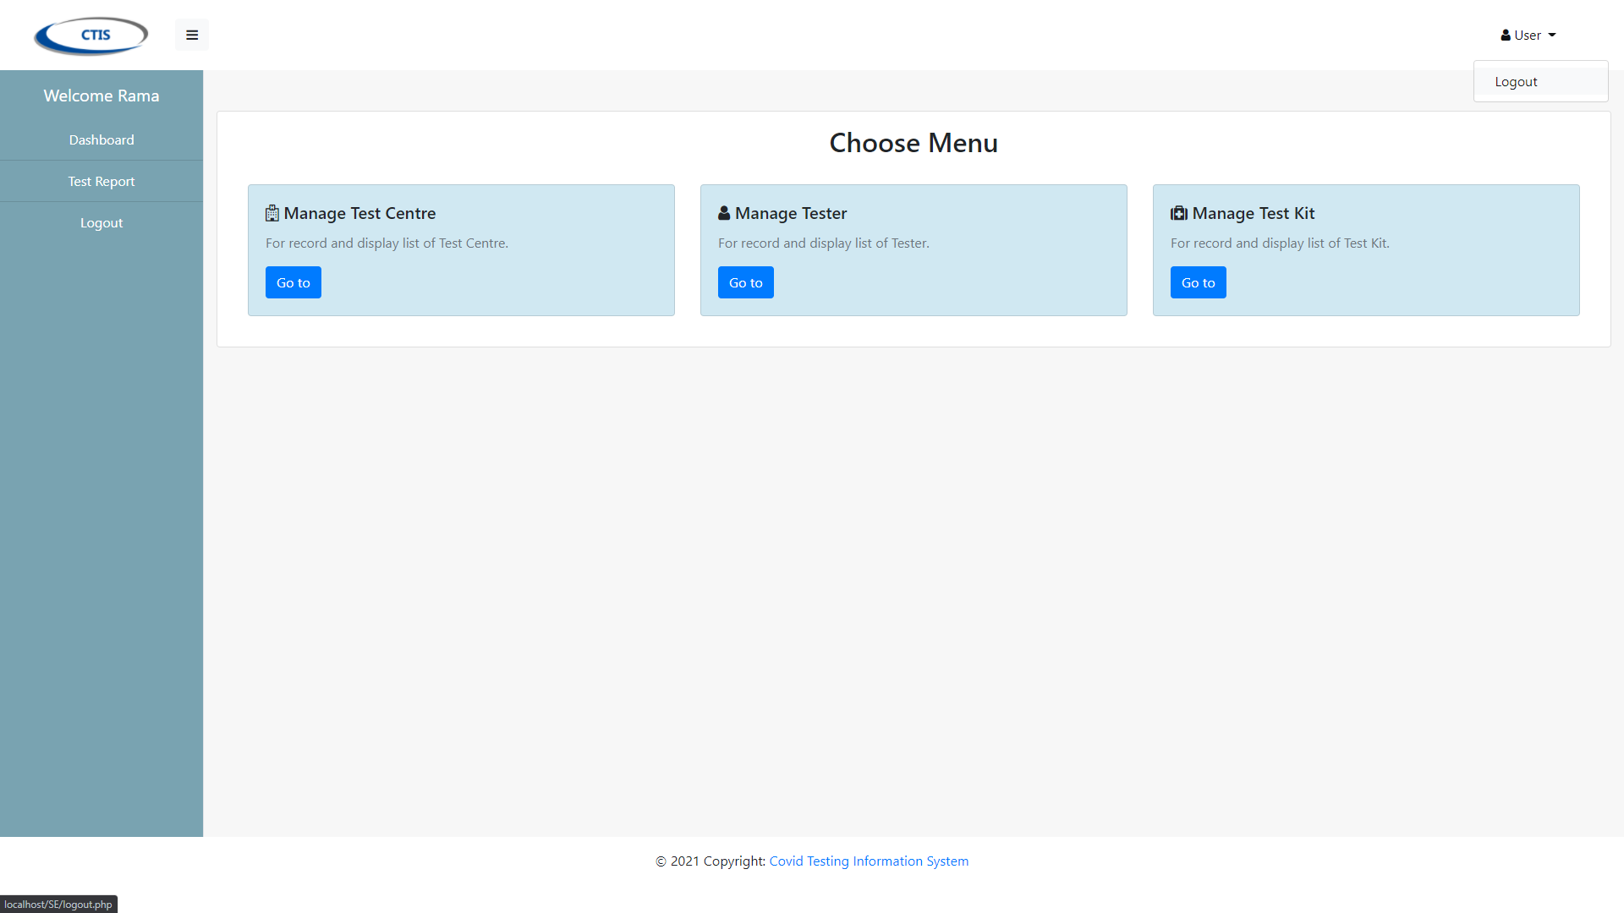

Integration Testing

We are use Selenium Plug-in from Google Chrome for record the system will run based on the functions in each use case

1. Login & Logout Test Centre Manager

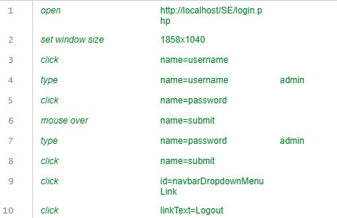

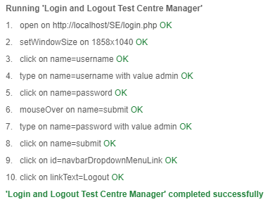

2. Login & Logout Tester

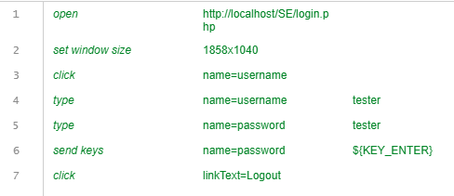

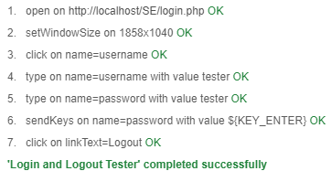

3. Login & Logout Patient

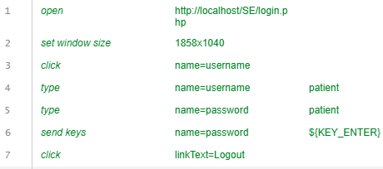

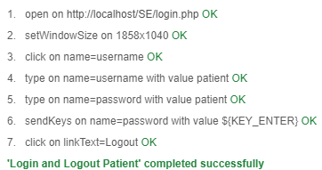

4. Register Test Centre

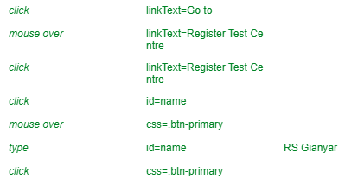

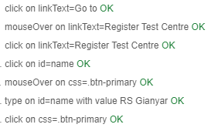

5. Record Tester

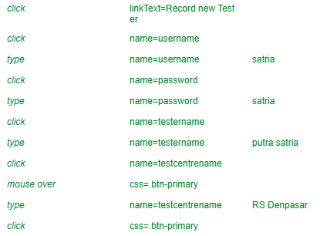

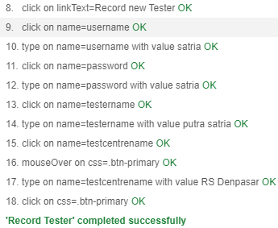

6. Generate Test Report

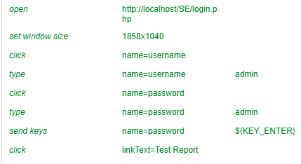

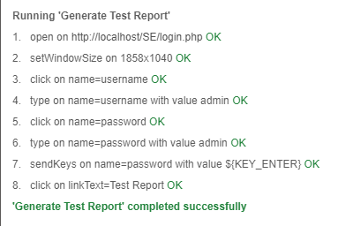

System Testing

1. Login

This is the login page that user start first



This is Test Centre Manager’s Dashboard



This is Tester’s Dashboard



This is Patient’s Dashboard



2. Manage Test Centre

This page is display all the test centre that has been registered



This page is display form registration of test centre



This Page shown message that successful registered

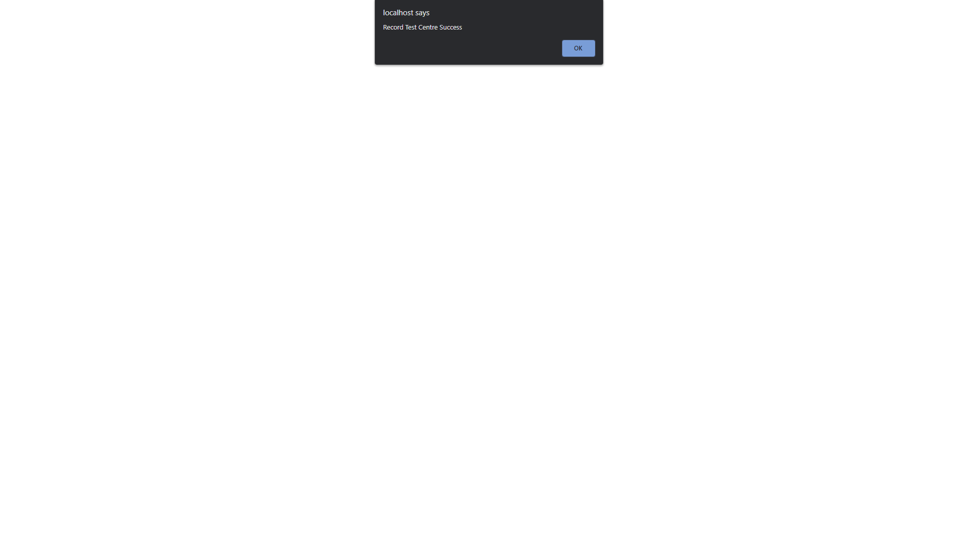

3. Record Tester

This page is display form record for tester



This page shown message that record tester is suceessfull



4. Generate Test Report

This page is display list all the test report that has been registered



5. Logout

This is page from Test Centre Manager that user want to logout and redirect to login page





Test Analysis Report

Asasasas

Update Gantt Chart

